

ESOFT Metro Campus
School of Computing
Bachelor of Information Technology Honours Batch 03 Level 04 – Semester 02 Assignment

ECU4308 – Enterprise Network Systems and Implementation

Time Allowed : 2 Weeks April 2026

Registration Number: E029590

INSTRUCTIONS TO CANDIDATES
- This assessment includes 5 tasks.
- Complete all the tasks.

Task 01
According to the given figure (figure 1), set-up the virtual environment. (VMware / Oracle virtual-box, pfSense)
Deploy the FW and login to the management interface.

Task 02
Create Vnets accordingly and established connections.

Task 03
Enable Internet connectivity for PC 1 and PC 2.

Task 04
Block ‘Youtube’ service for PC 1 Block ‘Whatsapp’ service for PC 2

Task 05
Create a fully detailed report adding relevant figures.

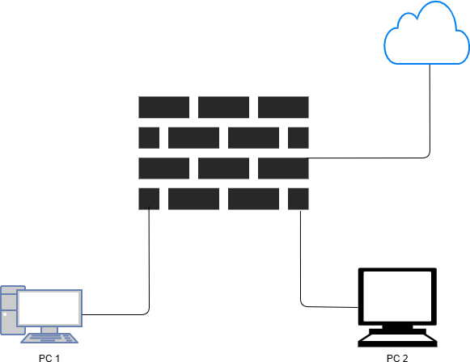
Figure 1

**Attending viva is compulsory to complete the Assignment

END OF ASSIGNMENT

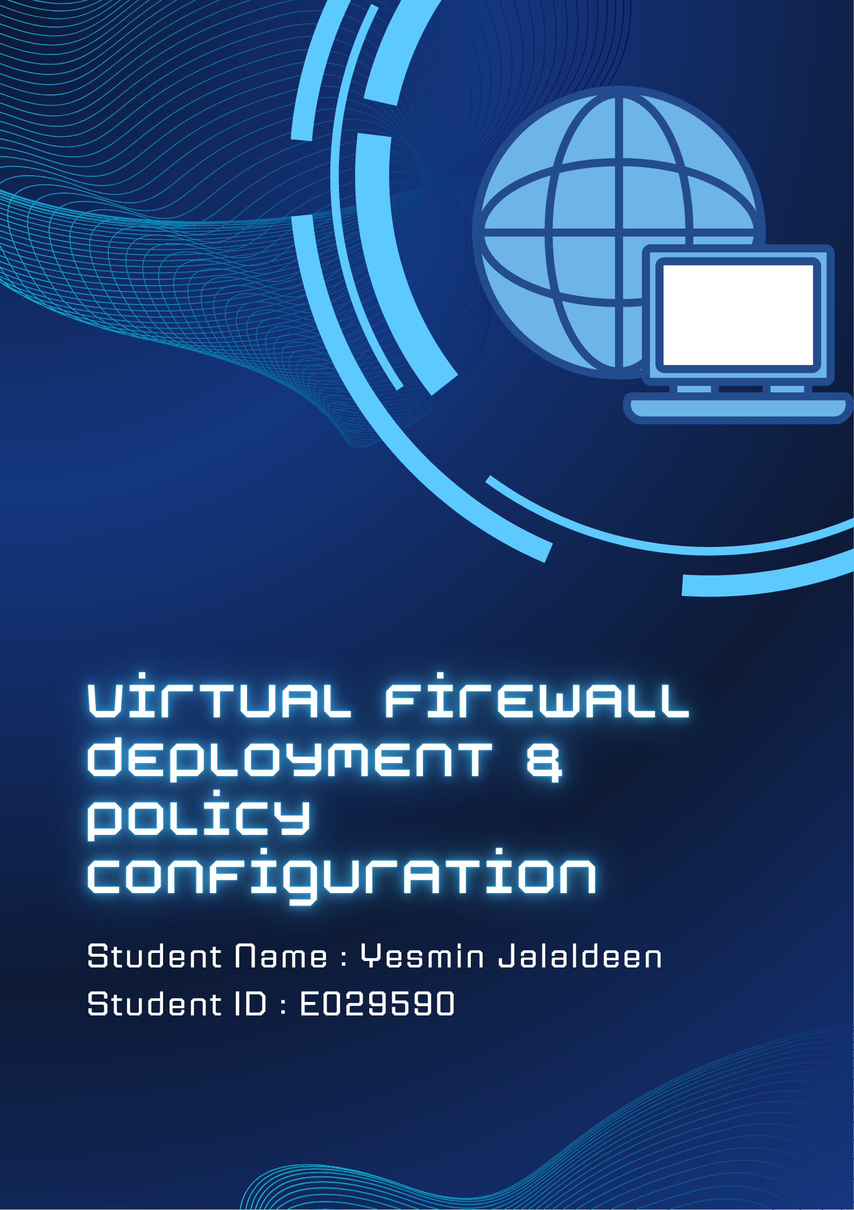

Acknowledgement

I would like to express my sincere gratitude to Mr. Pasan Kavindya, theory and tutorial lecturer for the Enterprise Network Systems and Implementation module, for his valuable guidance, continuous support, and encouragement throughout this assignment. His lectures, practical demonstrations, and technical explanations greatly contributed to improving my understanding of enterprise networking concepts, virtualization, firewall implementation, and network security configurations.

I would like to extend my appreciation to my friends and colleagues for their support, suggestions, and assistance during the troubleshooting and testing stages of this practical implementation. Their encouragement and discussions helped me overcome several technical challenges encountered throughout the assignment.

Table of Contents

ECU4308 – Enterprise Network Systems and Implementation 1
Acknowledgement 4
Table of Contents 5
List of Tables 6
List of Figures 6
Virtual Firewall Deployment & Policy Configuration 8
Introduction 8
Network Topology Overview 9
VM Selections 9
Previous VM Selections & Issues Encountered 12
Logical Network Diagram 15
Network Address Summary 17
Virtual Network Adapter Configuration 18
Task 01 : Virtual Environment Setup & pfSense Deployment 21
Step-by-Step Configuration of Task 01 21
Step 1 : Installing Oracle VirtualBox 21
Step 2 : Deploying pfSense Firewall 22
Step 2.1 : pfSense Web GUI Interface Management 23
Step 3 : Setting Up PC1 (Ubuntu Desktop) 31
Step 4 : Setting Up PC2 (Lubuntu 24.04 LTS) 32
Challenges Faced & Troubleshooting 33
Task 02 : Creating Virtual Networks (VNets) & Establishing Connections 35
Step-by-Step Configuration of Task 02 35
Step 1 : Configuring pfSense Network Adapters 35
Step 2 : Configuring Ubuntu (PC1) Network Adapter 37
Step 3 : Configuring Lubuntu (PC2) Network Adapter 37
Step 4 : Booting pfSense and Verifying Interface Assignment 38
Step 5 : Verifying Ubuntu (PC1) Connectivity 39
Step 6 : Verifying Lubuntu (PC2) Connectivity 40
Challenges Faced & Troubleshooting 41
Task 03 : Enabling Internet Connectivity for PC1 and PC2 45
Internet Connectivity in This Topology 45
Internet Connectivity Verification : Ubuntu (PC1) 46
Internet Connectivity Verification : Lubuntu (PC2) 46
Final Network Connectivity Summary 47
Task 04 : Blocking Services for PC1 and PC2 48
Selected Approach : Firewall Rules with IP Aliases 48
Methods Attempted Before Final Implementation 50
Method 1 - DNS Resolver Global Blocking 50
Method 2 - Hybrid DNS and Firewall Approach 52
Step-by-Step Configuration for Task 04 52
Step 1 : Clearing DNS Resolver Custom Options 52
Step 2 : Creating the YouTube IP Alias 54
Step 3 : Creating the WhatsApp IP Alias 55
Step 4 : Creating Firewall Rule to Block YouTube for PC1 56
Step 5 : Creating Firewall Rule to Block WhatsApp for PC2 57
Step 6 : Applying Changes and Flushing DNS Cache 58
Challenges Faced & Troubleshooting 60
Conclusion 63
Lessons Learned 64

List of Tables

Table 1 : IP Address Allocation Summary 17
Table 3 : pfSense Network Adapter Details 35
Table 4 : pfSense Interface Assignment 38
Table 5 : Lubuntu IP Setting 42
Table 6 : Network Connectivity Summary 47

List of Figures

Figure 1 : pfSense CLI Mode 10
Figure 2 : Ubuntu OS 11
Figure 3 : Lubuntu OS 12
Figure 4 : Kali Linux OS 13
Figure 5 : Linux Mint OS (Cinnamon Version) 14
Figure 6 : Linux Mint OS (MATE Version) 15
Figure 7 : Logical Network Diagram 16
Figure 8 : pfSense Network Adapter Configurations 19
Figure 9 : Ubuntu OS Network Adapter Configuration Settings 19
Figure 10 : Lubuntu OS Network Adapter Configuration Settings 20
Figure 11 : Oracle VirtualBox Setup Installation 21
Figure 12 : Oracle VirtualBox 22
Figure 13 : Netgate Firewall Installer 23
Figure 14 : pfSense Firewall CLI 23
Figure 15 : pfSense Firewall GUI 24
Figure 16 : pfSense Setup Wizard 25
Figure 17 : pfSense General Information 26
Figure 18 : pfSense Time Server 27
Figure 19 : pfSense Configure WAN 27
Figure 20 : pfSense Configure LAN 28
Figure 21 : pfSense Admin Setting 29
Figure 22 : pfSense Reload 29
Figure 23 : pfSense Config Applied 30
Figure 24 : pfSense Dashboard 30
Figure 25 : Ubuntu VM Configuration 31
Figure 26 : Ubuntu OS Desktop 31
Figure 28 : Lubuntu Installation 32
Figure 27 : Lubuntu VM Configuration 32
Figure 29 : Lubuntu OS Desktop 33
Figure 30 : pfSense WAN Adapter VM Config 36
Figure 31 : pfSense LAN Adapter VM Config 36
Figure 32 : Ubuntu LAN Adapter VM Config 37
Figure 33 : Lubuntu LAN Adapter VM Config 38
Figure 34 : pfSense Interface Setting 39
Figure 35 : pfSense Interface IPs 39
Figure 36 : Ubuntu IP Address Verification 40
Figure 37 : Lubuntu IP Address Verification 40
Figure 38 : Incorrect Network Configuration 41
Figure 39 : Fixed Network Configuration 42
Figure 40 : Lubuntu Static IP Config 43
Figure 41 : Lubuntu Terminal with Two IPs 44
Figure 42 : Lubuntu Terminal with one IP 44
Figure 43 : pfSense Default Gateway IP Address 45
Figure 44 : Ubuntu PC1 Internet Connectivity 46
Figure 45 : Lubuntu PC2 Internet Connectivity 47
Figure 46 : Firewall Rules 49
Figure 47 : pfSense Firewall Aliases 49
Figure 48 : pfSense Firewall - DNS Resolver pt.1 51
Figure 49 : pfSense Firewall - DNS Resolver pt.2 51
Figure 50 : pfSense Firewall - Clearing DNS Resolver 53
Figure 51 : pfSense Firewall YouTube_IPs Alias 54
Figure 52 : pfSense Firewall WhatsApp_IPs Alias 55
Figure 53 : pfSense Firewall Rule PC1 56
Figure 54 : pfSense Firewall Rule PC2 57
Figure 55 : pfSense Firewall Rules Applied 58
Figure 56 : DNS Flush on PC1 59
Figure 57 : DNS Flush on PC2 59
Figure 58 : PC1 YouTube Blocked Result 61
Figure 59 : PC1 WhatsApp Access Result 61
Figure 60 : PC2 WhatsApp Blocked Result 62
Figure 61 : PC2 YouTube Access Result 62

Virtual Firewall Deployment & Policy Configuration

Introduction

This report presents the design, deployment, configuration, and testing of a virtualized enterprise network environment developed using Oracle VirtualBox and pfSense. The implementation was carried out to simulate a small-scale enterprise network infrastructure capable of centralized internet management, secure traffic routing, network segmentation, and client specific access control policies.

The environment consisted of a pfSense firewall/router acting as the central gateway device and two Linux based client operating systems functioning as internal workstations within the LAN environment. A mobile hotspot connection was utilized as the WAN internet source for the entire network.

The practical implementation demonstrated several enterprise networking concepts including:
- Virtual network deployment
- Firewall implementation
- WAN and LAN segmentation
- NAT based internet connectivity
- Client specific firewall rule enforcement
- Controlled service access restrictions
- Virtual machine resource optimization
- Enterprise troubleshooting methodologies

Throughout the implementation process, several practical challenges were encountered including operating system compatibility issues, virtualization limitations, installer failures, and resource constraints. These issues required troubleshooting, redesign decisions, and alternative implementation approaches similar to real world enterprise deployment environments.

Network Topology Overview

The implemented network follows a centralized hub and spoke enterprise topology where pfSense acts as the perimeter firewall and gateway between the internal LAN and the external internet connection.

All inbound and outbound traffic is routed through the pfSense firewall, allowing centralized traffic management, NAT translation, firewall rule enforcement, and internet access control. The client machines were connected to an isolated internal network segment named "LAN NET", ensuring that no workstation could directly access the internet without passing through the firewall.

This architecture closely resembles real world enterprise environments where endpoint devices are protected behind a centralized perimeter firewall.

VM Selections

- Firewall : pfSense CE
pfSense CE was selected as the firewall and routing platform because it is a lightweight, enterprise grade open source firewall operating system based on FreeBSD. It includes built-in enterprise networking features such as NAT, firewall rule management, DNS services, interface management, and routing capabilities, making it ideal for simulating real world enterprise firewall environments within a virtualized lab setup.
Another reason for selecting pfSense was its compatibility with Oracle VirtualBox and its low hardware resource requirements, allowing stable operation alongside multiple client virtual machines on the host system.

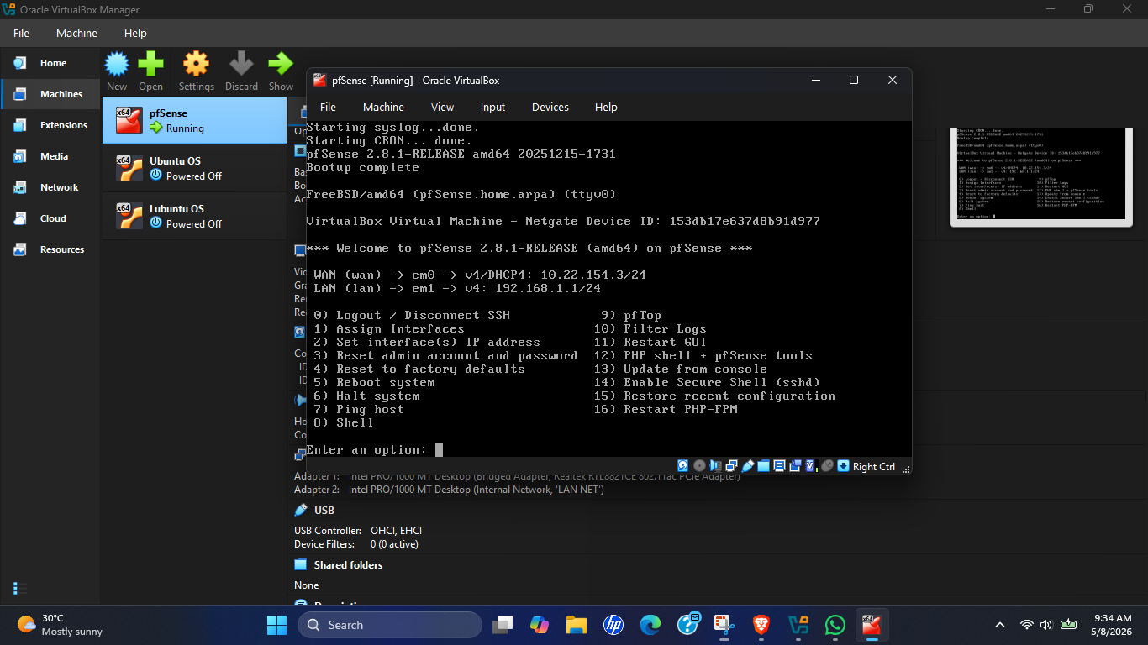
Figure 1 : pfSense CLI Mode

- PC1 : Ubuntu Desktop (Final Choice)
Ubuntu Desktop 64-bit was selected as PC1 because it provides a stable and fully featured Linux desktop environment suitable for enterprise networking simulations. Ubuntu includes built-in networking tools, terminal utilities, and web browsers required for testing internet connectivity and firewall policy enforcement.

Ubuntu was also chosen due to its strong VirtualBox compatibility, smooth installation process, and stable performance throughout the implementation. The operating system functioned reliably without major compatibility or performance issues during testing.
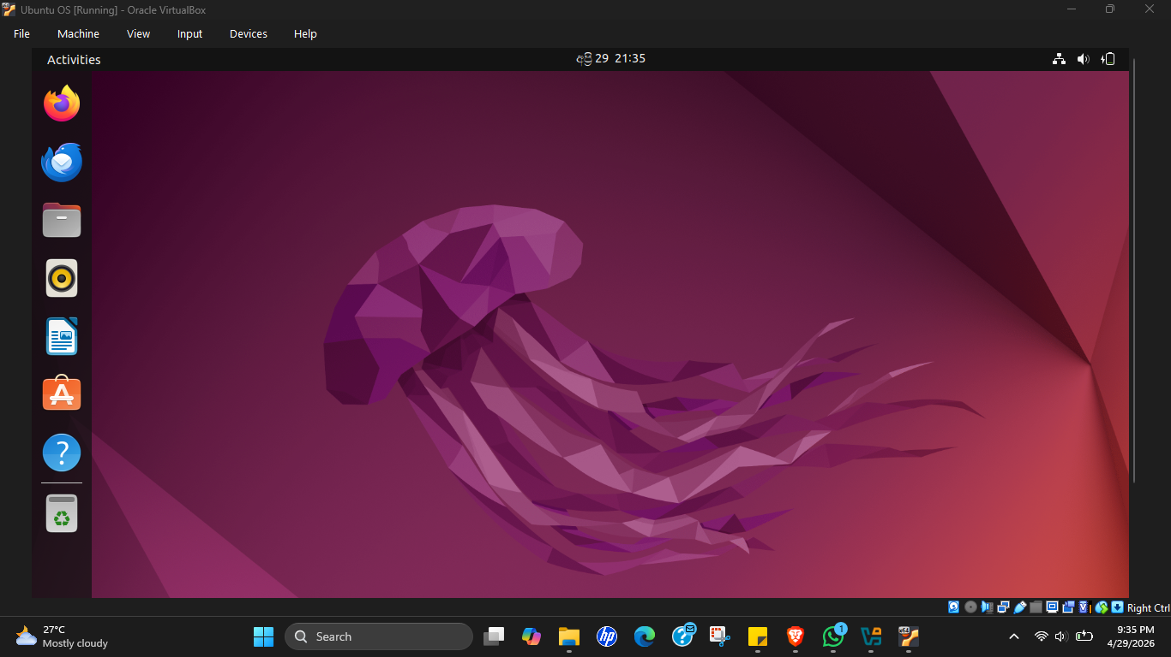
Figure 2 : Ubuntu OS

- PC2 : Lubuntu 24.04 LTS (Final Choice)
Lubuntu 24.04 LTS was selected as the final operating system for PC2 after evaluating multiple lightweight Linux alternatives. Lubuntu uses the LXQt desktop environment, which consumes significantly fewer system resources compared to full desktop distributions such as Linux Mint Cinnamon.

This lightweight architecture was especially important because the host machine contained only 8GB of RAM and needed to simultaneously run pfSense, Ubuntu, and another client operating system without causing system instability or excessive slowdown. Lubuntu also maintained full Linux networking functionality while significantly improving virtual machine performance and overall system responsiveness.
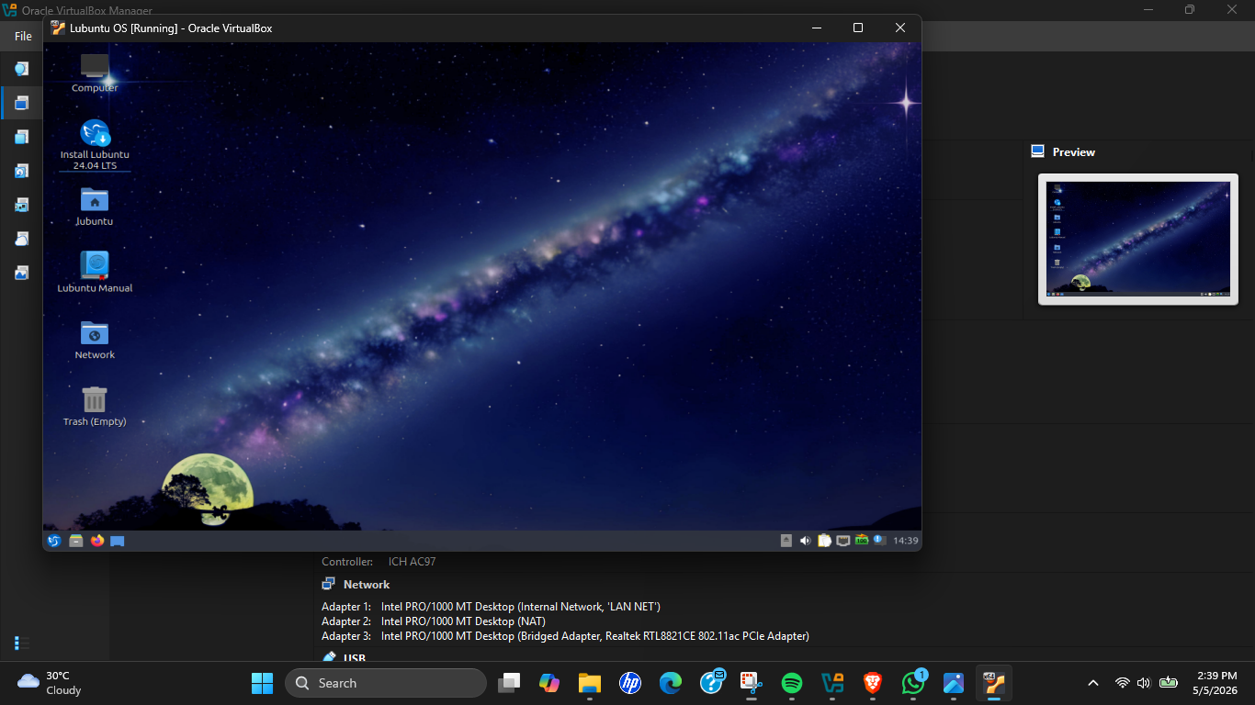
Figure 3 : Lubuntu OS

Previous VM Selections & Issues Encountered

Before finalizing the implementation environment, several operating systems were tested and evaluated to determine the most stable and resource efficient solution.

Initial Attempt : Kali Linux
Kali Linux was initially considered due to its popularity within networking and cybersecurity environments. The operating system includes advanced networking and penetration testing tools which could be useful for enterprise security testing and troubleshooting activities.

However, Kali Linux was ultimately not selected because the operating system introduced unnecessary resource overhead and additional packages that were not required for the assignment objectives. Since the practical focused primarily on firewall deployment, internet connectivity, and service restriction testing, a lighter and more stable client operating system was considered more appropriate.
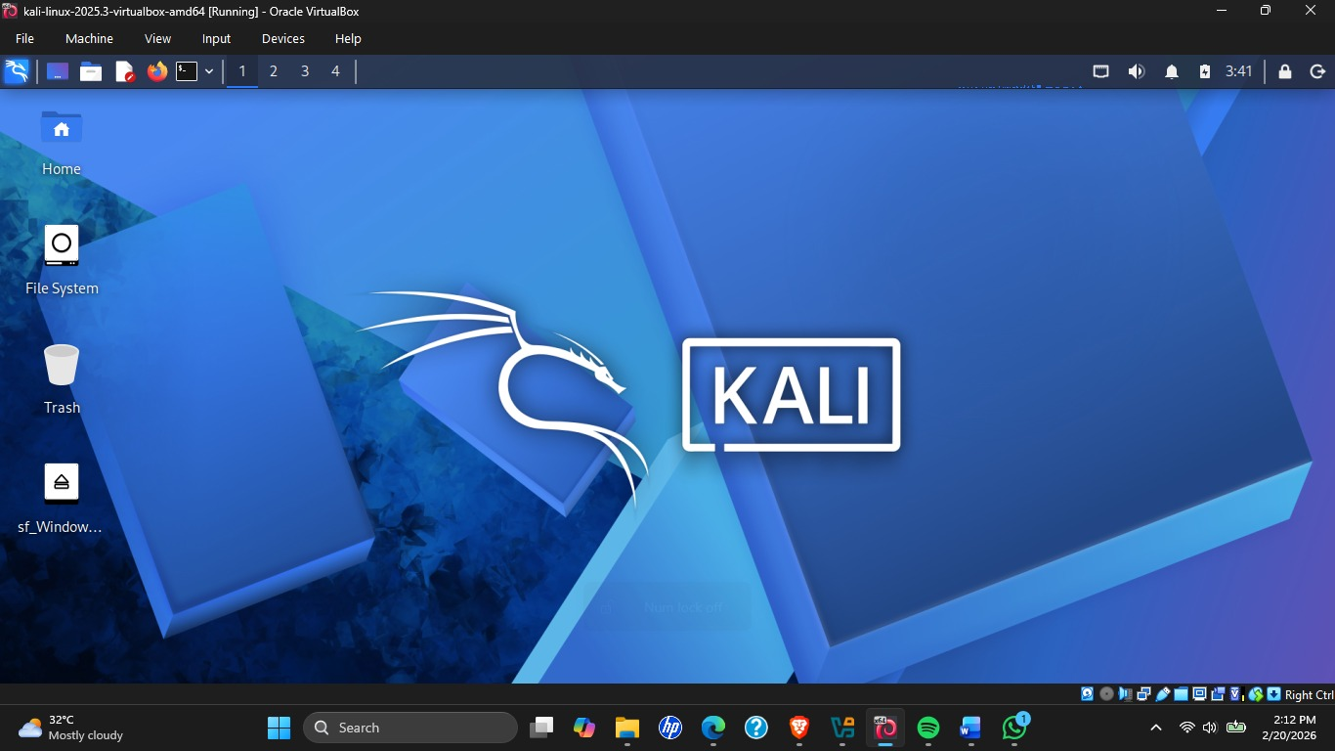
Figure 4 : Kali Linux OS

Second Attempt : Linux Mint Cinnamon
Linux Mint Cinnamon was initially attempted as the second client operating system because of its modern user friendly interface and strong Ubuntu based compatibility.

However, the Cinnamon desktop environment consumed a large amount of system memory and processing resources. Running Linux Mint Cinnamon simultaneously with pfSense and Ubuntu caused significant performance degradation on the host machine due to the 8GB RAM limitation. This resulted in severe lag, delayed VM responsiveness, and reduced overall system stability during testing.
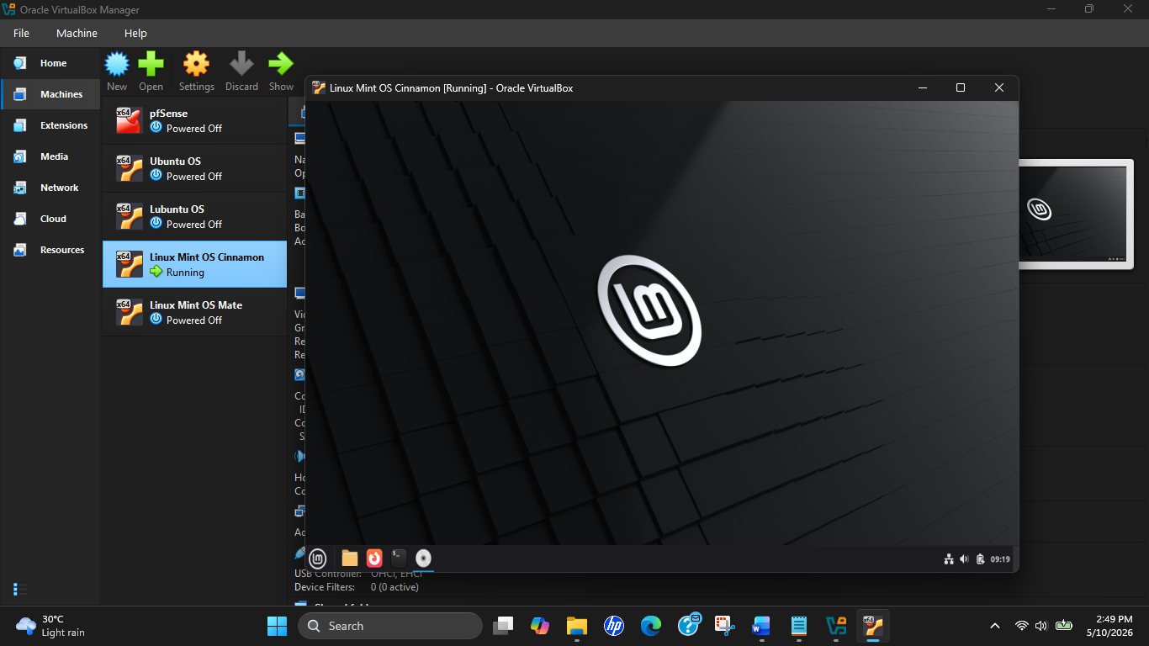
Figure 5 : Linux Mint OS (Cinnamon Version)

Third Attempt : Linux Mint MATE
Linux Mint MATE edition was then attempted as a lighter alternative to Cinnamon. The MATE desktop environment was expected to reduce resource consumption while still maintaining the Ubuntu based ecosystem. Although the ISO image was successfully downloaded and the virtual machine configuration was completed correctly, the graphical installer repeatedly failed to load and became unresponsive during installation attempts.

Multiple troubleshooting methods were attempted including:
• Increasing allocated RAM
• Increasing video memory
• Enabling 3D acceleration
• Using compatibility mode installation
• Adjusting VirtualBox display settings
Despite these troubleshooting efforts, the installer remained unresponsive and the operating system could not be deployed successfully.
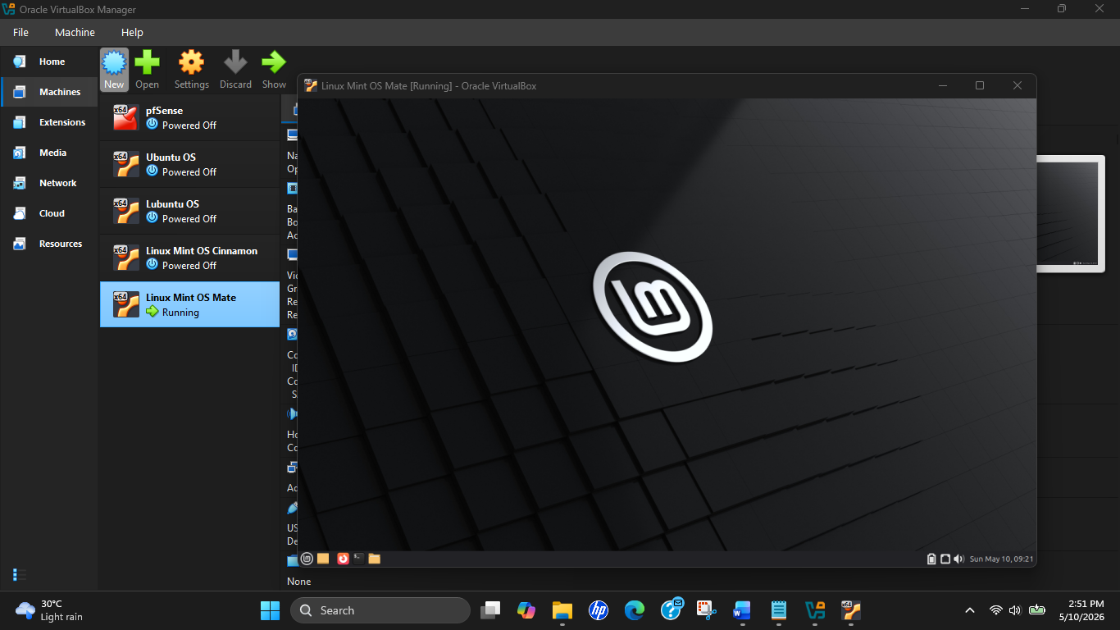
Figure 6 : Linux Mint OS (MATE Version)

Logical Network Diagram

The final network topology was designed using a centralized firewall architecture where pfSense functions as the core gateway device between the external internet connection and the internal LAN environment.

The mobile hotspot acted as the WAN internet source and was connected to the pfSense WAN interface using Bridged Adapter mode. This allowed pfSense to directly obtain internet connectivity through DHCP from the hotspot connection.

The pfSense LAN interface was configured using the private IP range: 192.168.1.0/24

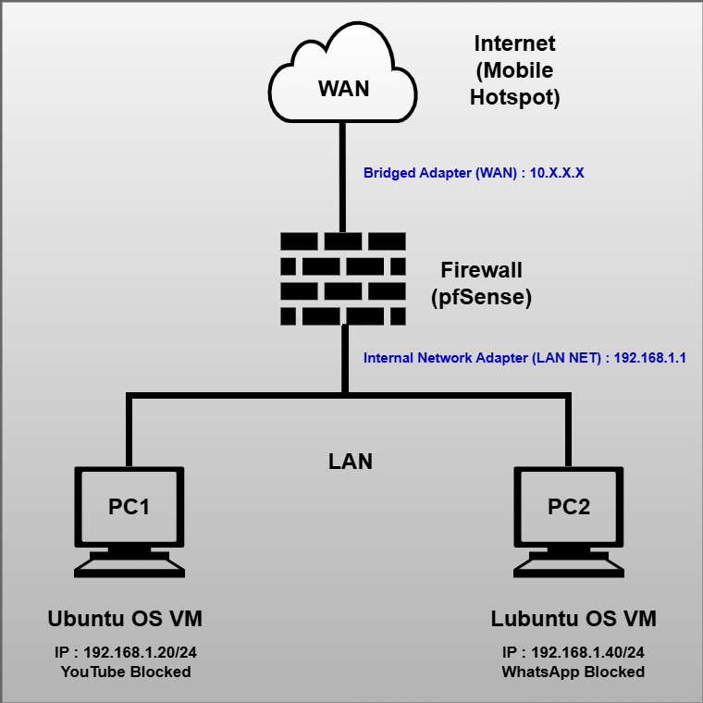
Figure 7 : Logical Network Diagram

Both client systems, Ubuntu and Lubuntu, were connected to the same isolated internal network segment named "LAN NET". This ensured that all traffic from both clients was forced through pfSense before reaching the internet.

Separate firewall rules were later implemented to apply different service restrictions to each client system:
- PC1 Ubuntu → YouTube Blocked
- PC2 Lubuntu → WhatsApp Blocked
This demonstrated client specific policy enforcement similar to enterprise firewall environments where different users or departments may have different internet access permissions

Network Address Summary

The network addressing structure was designed using manually assigned static IP addresses to ensure stable client identification and reliable firewall policy enforcement.

Static IP allocation was preferred over DHCP because client specific firewall rules required consistent source IP addresses. Dynamic IP allocation could potentially cause firewall rule mismatches if addresses changed during testing or system restarts.

The private subnet: 192.168.1.0/24 was selected because it is a standard RFC1918 private address range commonly used in enterprise LAN deployments.

Device | Interface | IP Address | Role
Mobile Hotspot | : | DHCP Provider | Internet Source
pfSense WAN | em0 (Bridged) | 10.22.154.3/24 | WAN Gateway
pfSense LAN | em1 (LAN NET) | 192.168.1.1/24 | LAN Gateway
PC1 Ubuntu | enp0s3 | 192.168.1.20/24 | Client 1
PC2 Lubuntu | enp0s3 | 192.168.1.40/24 | Client 2
Table 1 : IP Address Allocation Summary
The IP address 192.168.1.1 was assigned to the pfSense LAN interface because the first usable address in a subnet is commonly utilized as the default gateway in enterprise environments.

PC1 Ubuntu and PC2 Lubuntu were manually assigned the addresses 192.168.1.20 and 192.168.1.40 respectively to simplify device identification and firewall rule management during service blocking implementation.

Virtual Network Adapter Configuration

The network adapters were configured to create a clear separation between the WAN and LAN environments while ensuring centralized firewall enforcement through pfSense.

pfSense VM : Adapter 1 - Bridged Adapter (Realtek Wi-Fi) = WAN

The first adapter was configured in Bridged Adapter mode and connected directly to the host machine’s Realtek Wi-Fi adapter. This allowed pfSense to behave as an independent physical device on the hotspot network and receive internet connectivity directly through DHCP. Bridged mode was selected because it provides more realistic WAN behavior compared to NAT mode and allows pfSense to fully manage internet routing independently from the host operating system.

pfSense VM : Adapter 2 - Internal Network “LAN NET” = LAN
The second adapter was configured as an Internal Network named “LAN NET”. This isolated virtual network allowed communication only between pfSense and the internal client machines. This design ensured that all client traffic passed through pfSense, enabling centralized NAT, DNS resolution, firewall filtering, and internet access control.
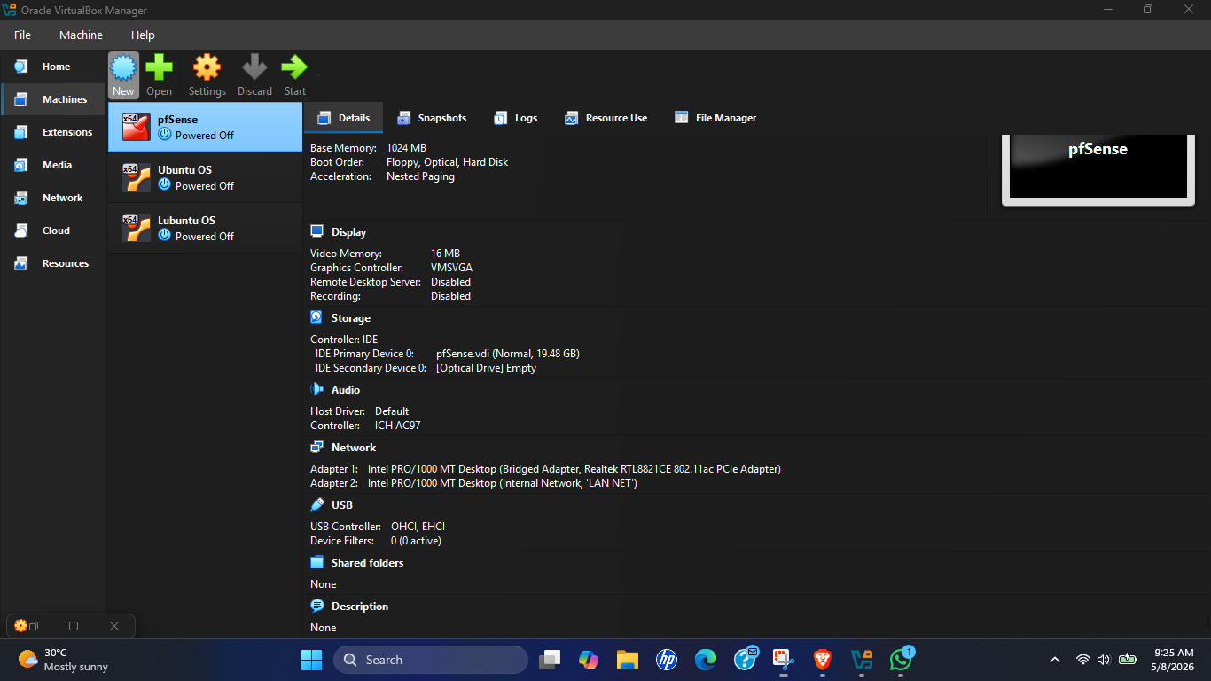
Figure 8 : pfSense Network Adapter Configurations

PC1 Ubuntu : Adapter 1 - Internal Network “LAN NET”
Ubuntu was connected directly to the isolated LAN_NET segment to ensure that all traffic flowed through pfSense before reaching the internet. This simulated a standard enterprise workstation located behind a centralized firewall.
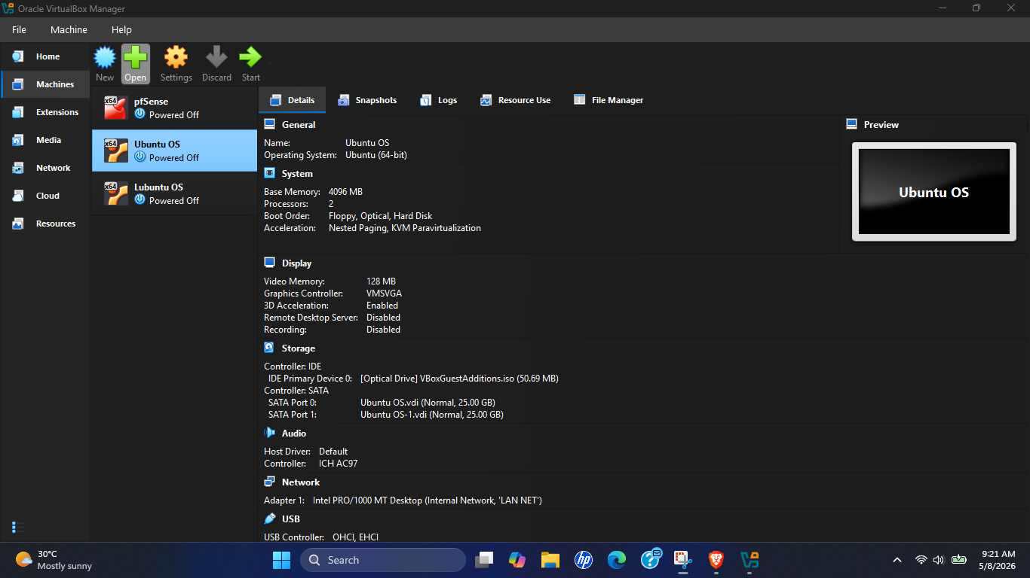
Figure 9 : Ubuntu OS Network Adapter Configuration Settings
PC2 Lubuntu : Adapter 1 - Internal Network “LAN NET”
Lubuntu was also connected to the same isolated LAN_NET environment, enabling communication through the pfSense firewall and allowing centralized traffic control. This configuration allowed separate firewall policies to be applied to each client machine based on manually assigned IP addresses.
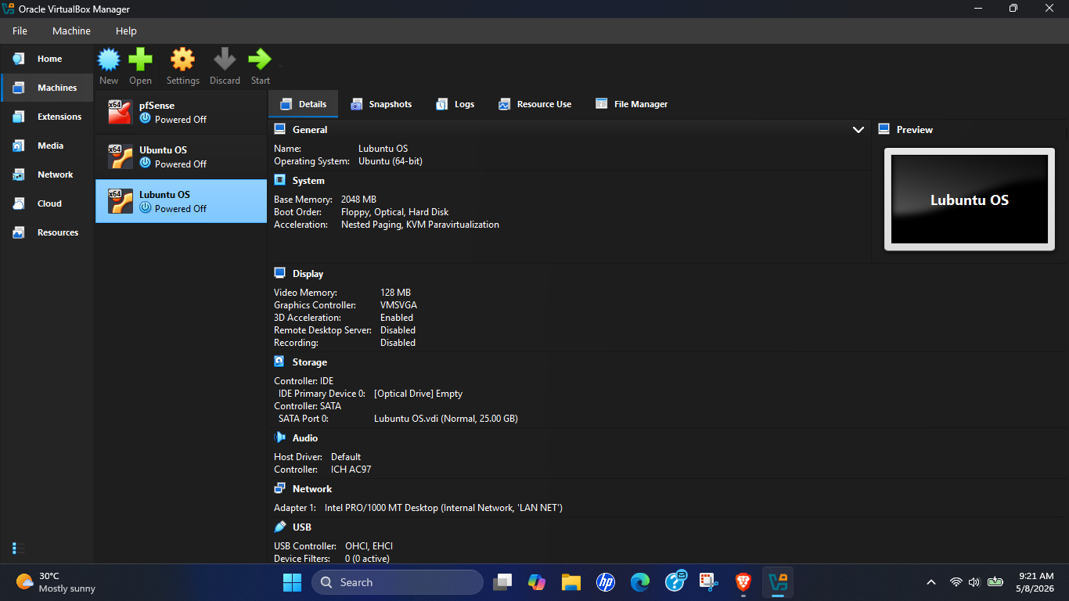
Figure 10 : Lubuntu OS Network Adapter Configuration Settings

Task 01 : Virtual Environment Setup & pfSense Deployment

The objective of Task 01 was to create a virtualized enterprise networking environment using Oracle VirtualBox, deploy pfSense as the centralized firewall/router, and configure two Linux-based client machines to simulate internal enterprise workstations.

Step-by-Step Configuration of Task 01

Step 1 : Installing Oracle VirtualBox

Oracle VirtualBox was downloaded and installed on the Windows host machine. The hypervisor served as the virtualization platform for deploying and managing all virtual machines throughout the assignment.

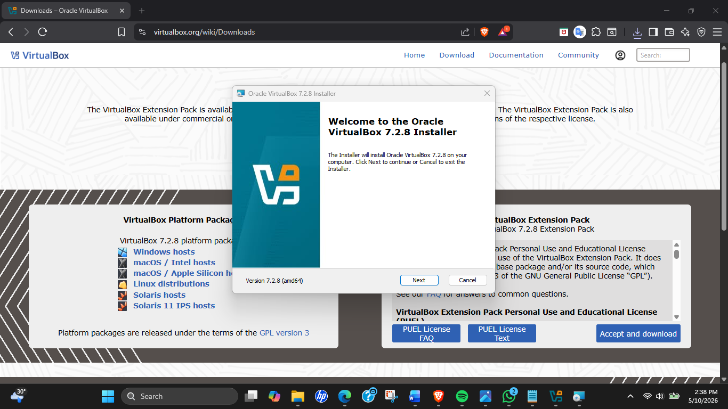
Figure 11 : Oracle VirtualBox Setup Installation
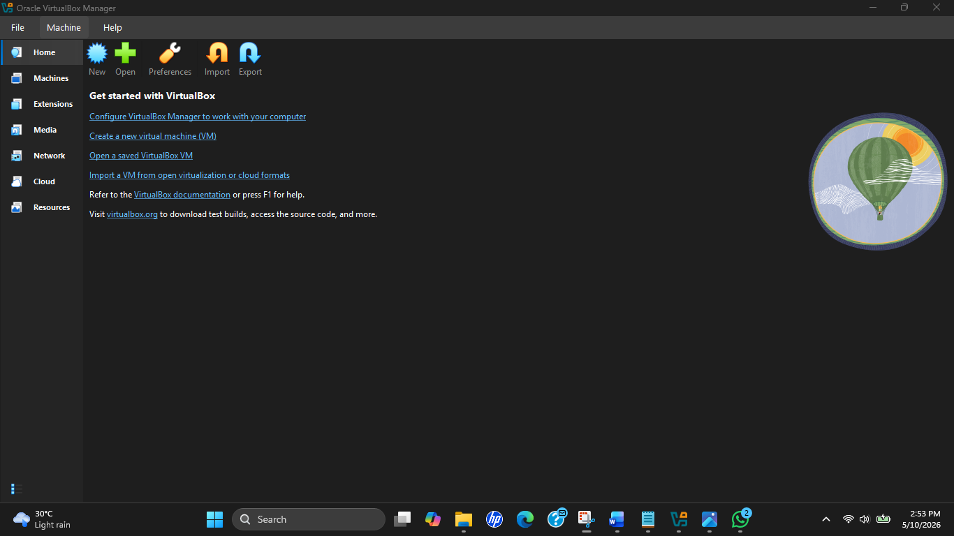
Figure 12 : Oracle VirtualBox
VirtualBox was selected because it supports multiple virtual networking modes including Bridged Adapter, NAT, and Internal Networking, which were essential for simulating the enterprise network architecture required for the practical implementation.

Step 2 : Deploying pfSense Firewall

The pfSense CE ISO image was downloaded and deployed as the primary firewall and routing device.
After attaching the pfSense ISO, the VM was booted and the installation process was completed successfully. The WAN and LAN interfaces were then assigned to their respective network adapters.
The pfSense management interface became accessible after configuring the LAN gateway address.
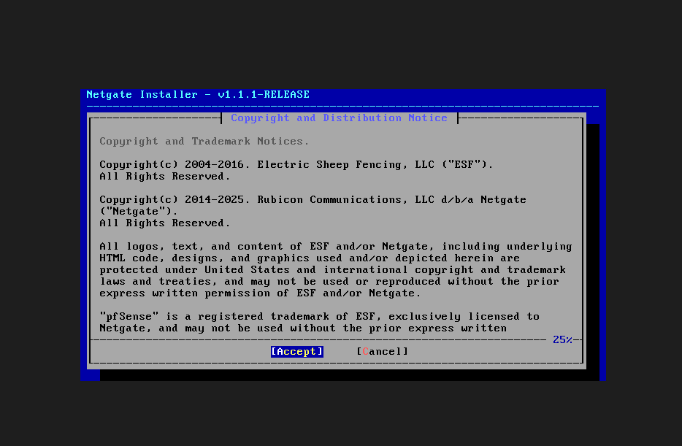
Figure 13 : Netgate Firewall Installer
Figure 14 : pfSense Firewall CLI

Step 2.1 : pfSense Web GUI Interface Management

After pfSense installation and interface assignment were completed, the pfSense web management interface was accessed through a web browser from the Ubuntu client machine.
The following URL was entered into the browser http://192.168.1.1
The default pfSense login credentials were used:
Username : admin Password : pfsense
After successful login, the pfSense Setup Wizard automatically launched to complete the initial firewall configuration.
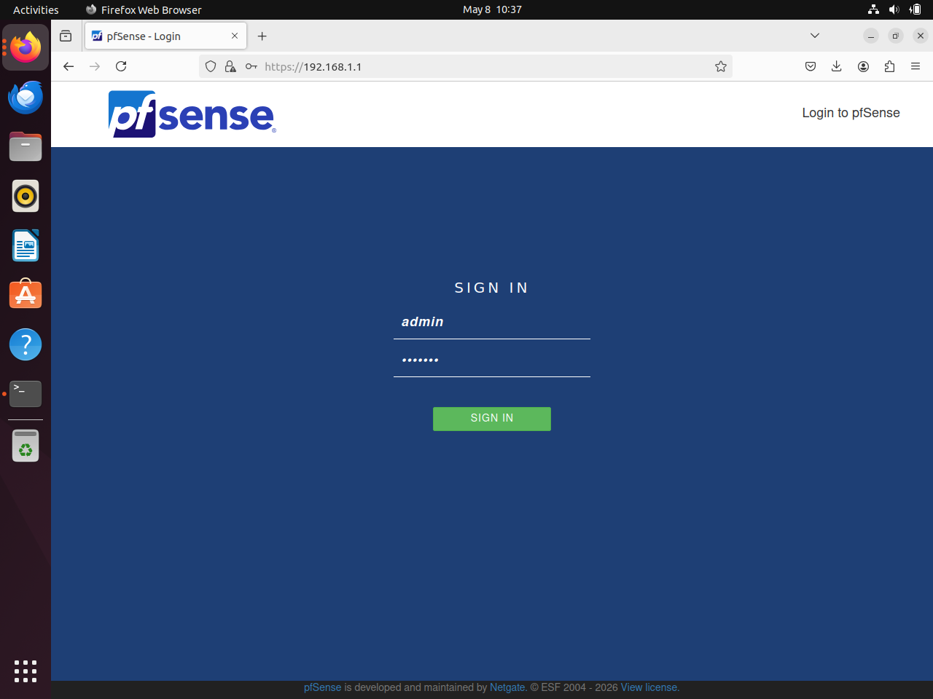
Figure 15 : pfSense Firewall GUI

Initial pfSense Setup Wizard Configuration
The pfSense Setup Wizard was completed to configure the basic firewall and network settings required for the enterprise network environment.

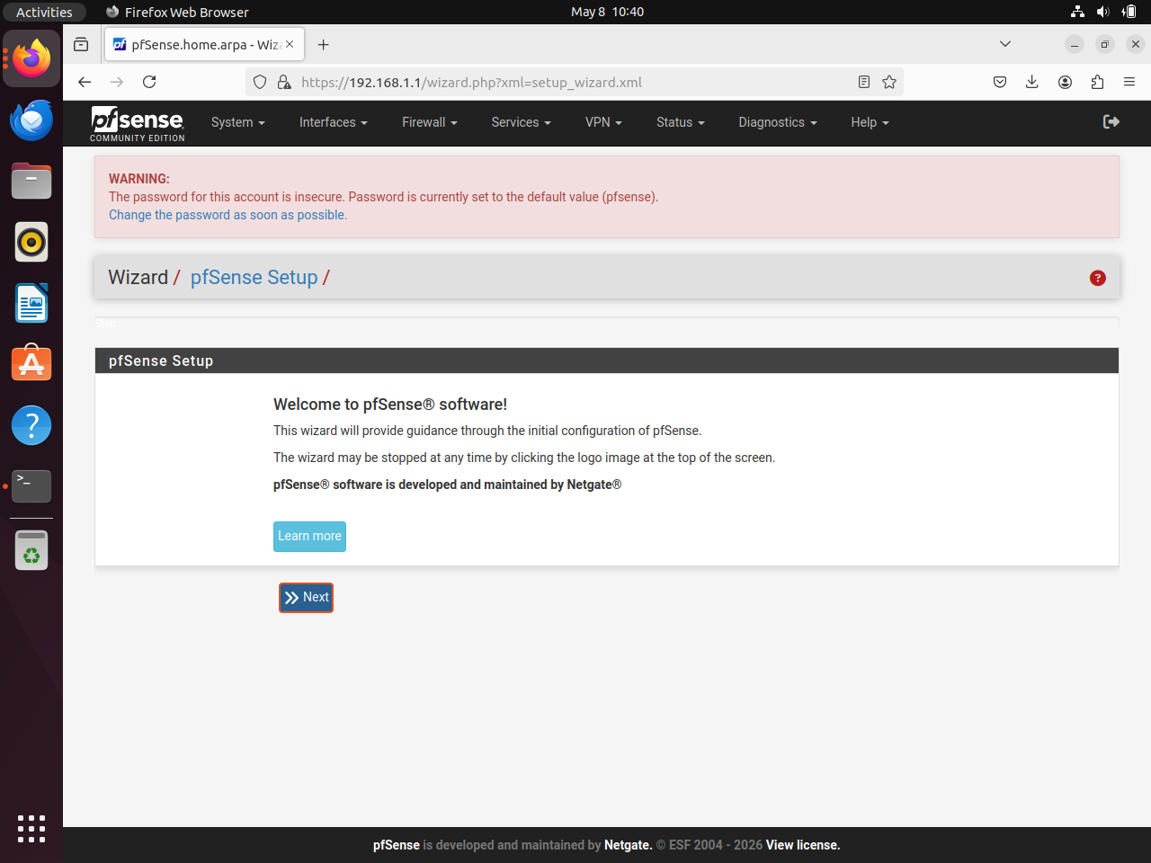
Figure 16 : pfSense Setup Wizard

Step 1 : General Information Configuration
The following system information was configured to provide reliable external DNS resolution for all LAN clients.
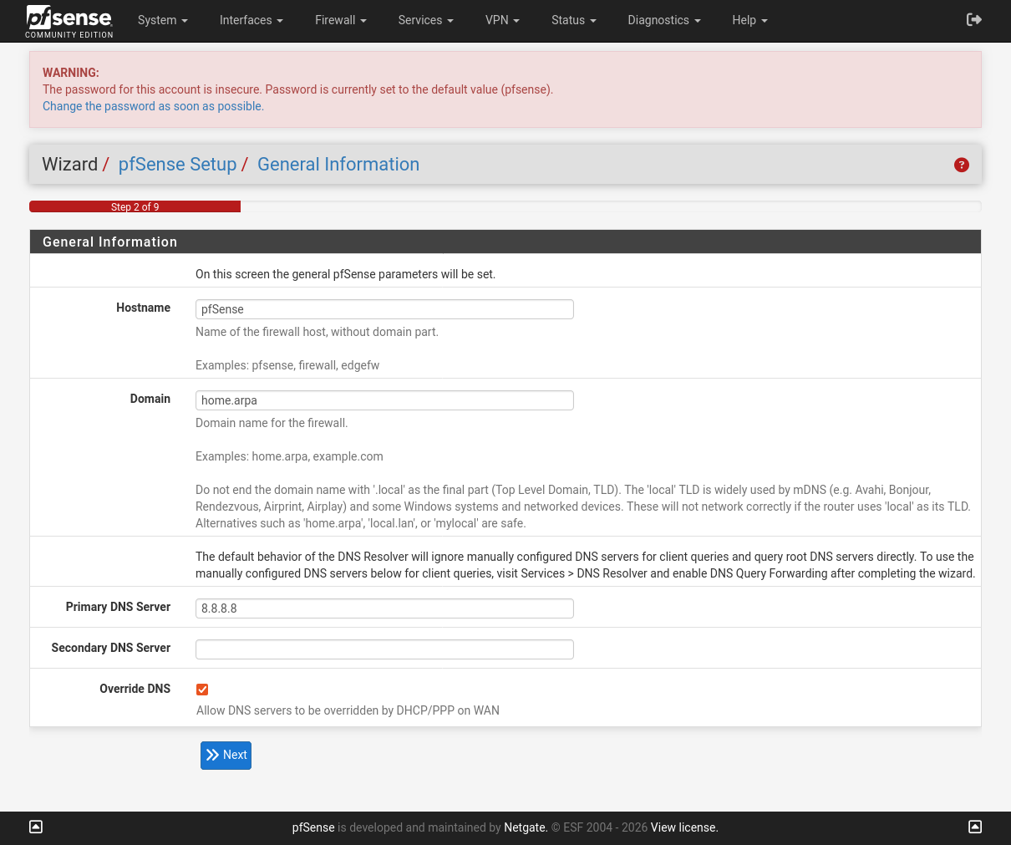
Figure 17 : pfSense General Information

Step 2 : Time Server Configuration
The default Network Time Protocol (NTP) settings provided by pfSense were retained. Accurate system time synchronization is important for firewall logging, monitoring, and troubleshooting within enterprise environments.
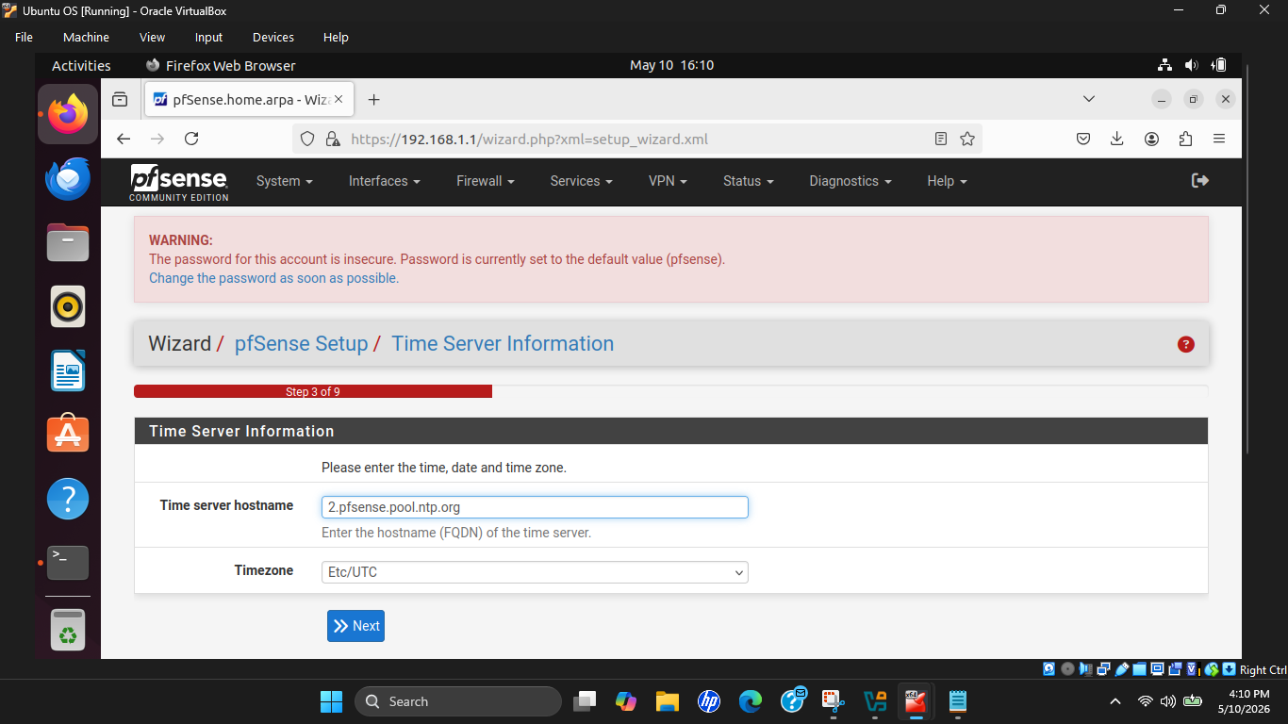
Figure 18 : pfSense Time Server
Step 3 : WAN Interface Configuration
The WAN interface was configured to obtain its IP address automatically using DHCP. This configuration was necessary because the WAN connection was provided through a mobile hotspot, which dynamically assigned IP addresses to connected devices. Although static IP addresses were manually assigned to the client virtual machines on the LAN side, the WAN interface remained independent and required DHCP to communicate with the hotspot network.
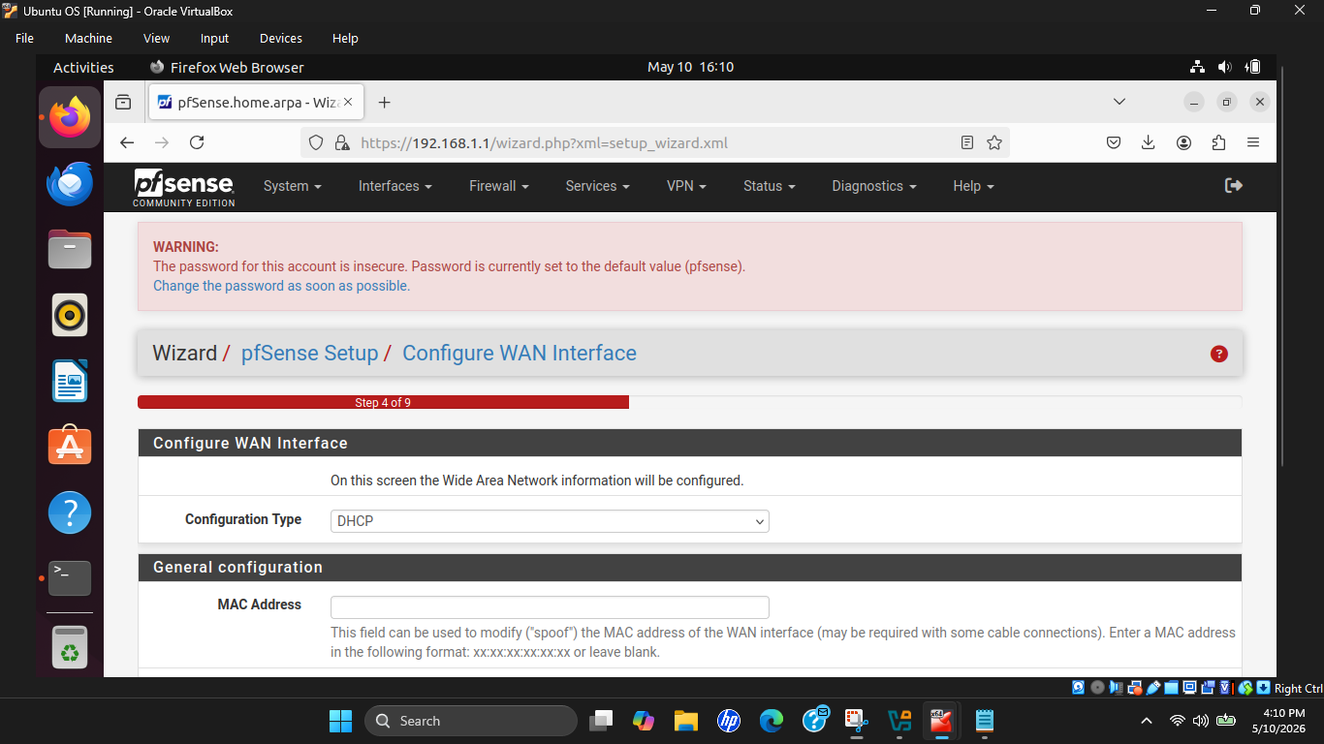
Figure 19 : pfSense Configure WAN
Step 4 : LAN Interface Configuration
The LAN interface was manually configured with the following settings because it is one of the standard RFC1918 private IP address ranges commonly used in enterprise and internal networks. pfSense therefore became the default gateway device for all internal client machines.
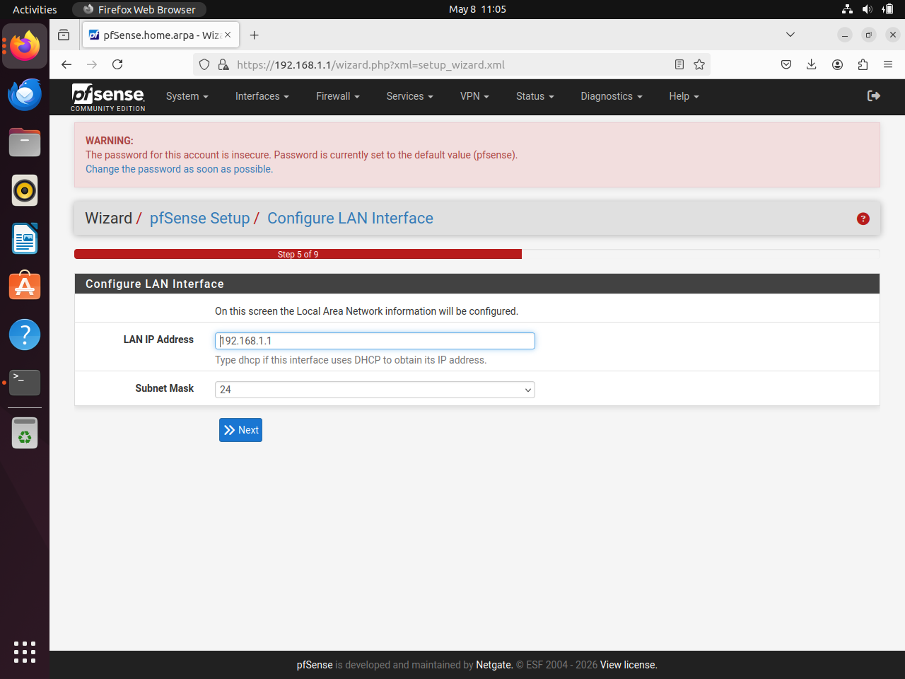
Figure 20 : pfSense Configure LAN

Step 5 : Administrative Password Configuration
The pfSense administrative password was configured through the setup wizard to secure access to the firewall management interface.
Changing the default administrative password is an important security practice in enterprise firewall deployments to prevent unauthorized access.
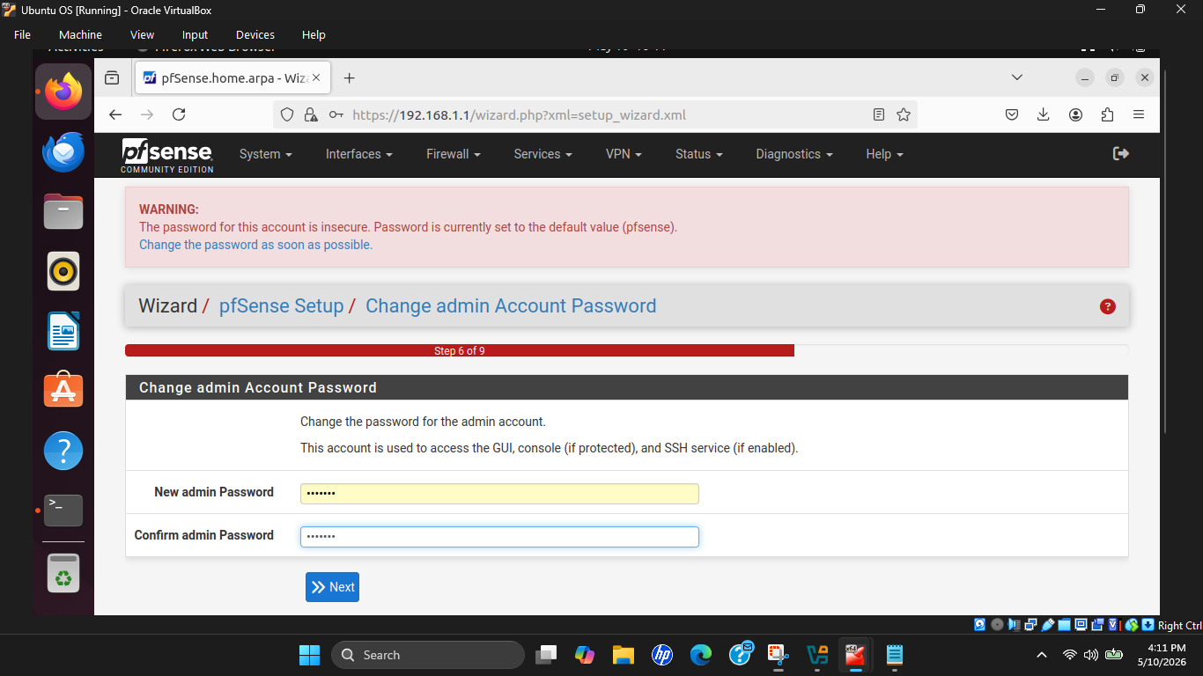
Figure 21 : pfSense Admin Setting

Step 6 : Reloading and Applying Configuration
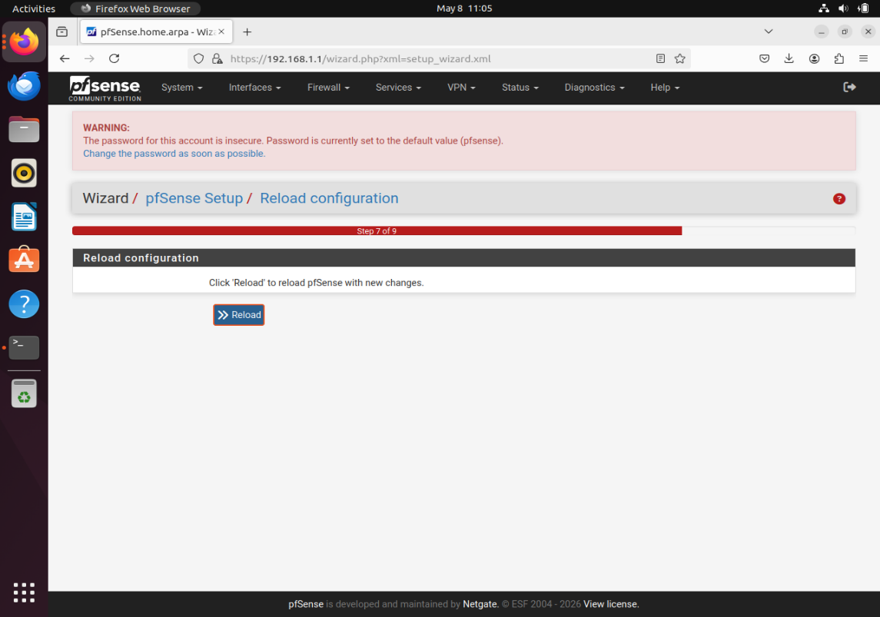
After completing the wizard, pfSense reloaded the configuration and applied all settings. The pfSense dashboard was then successfully displayed, confirming that the firewall deployment and initial configuration process had been completed successfully.
Figure 22 : pfSense Reload
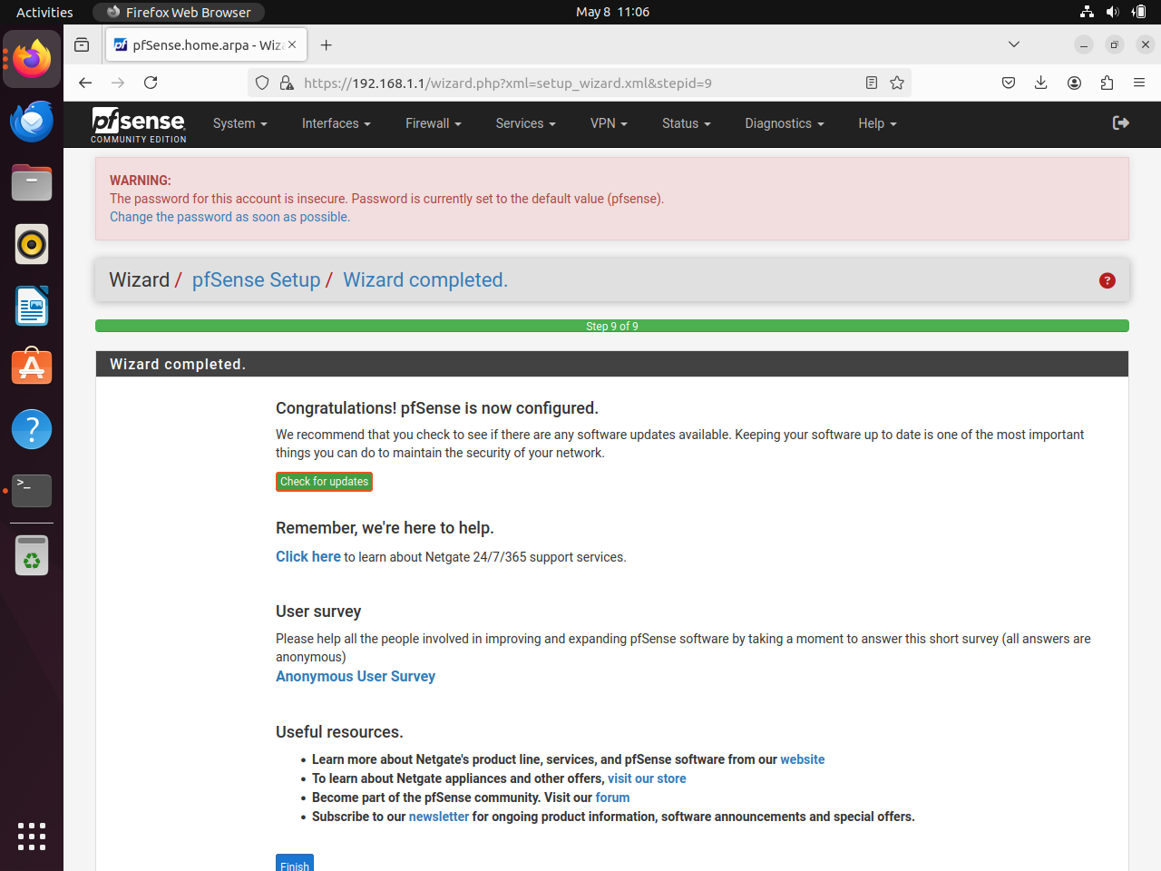
Figure 23 : pfSense Config Applied
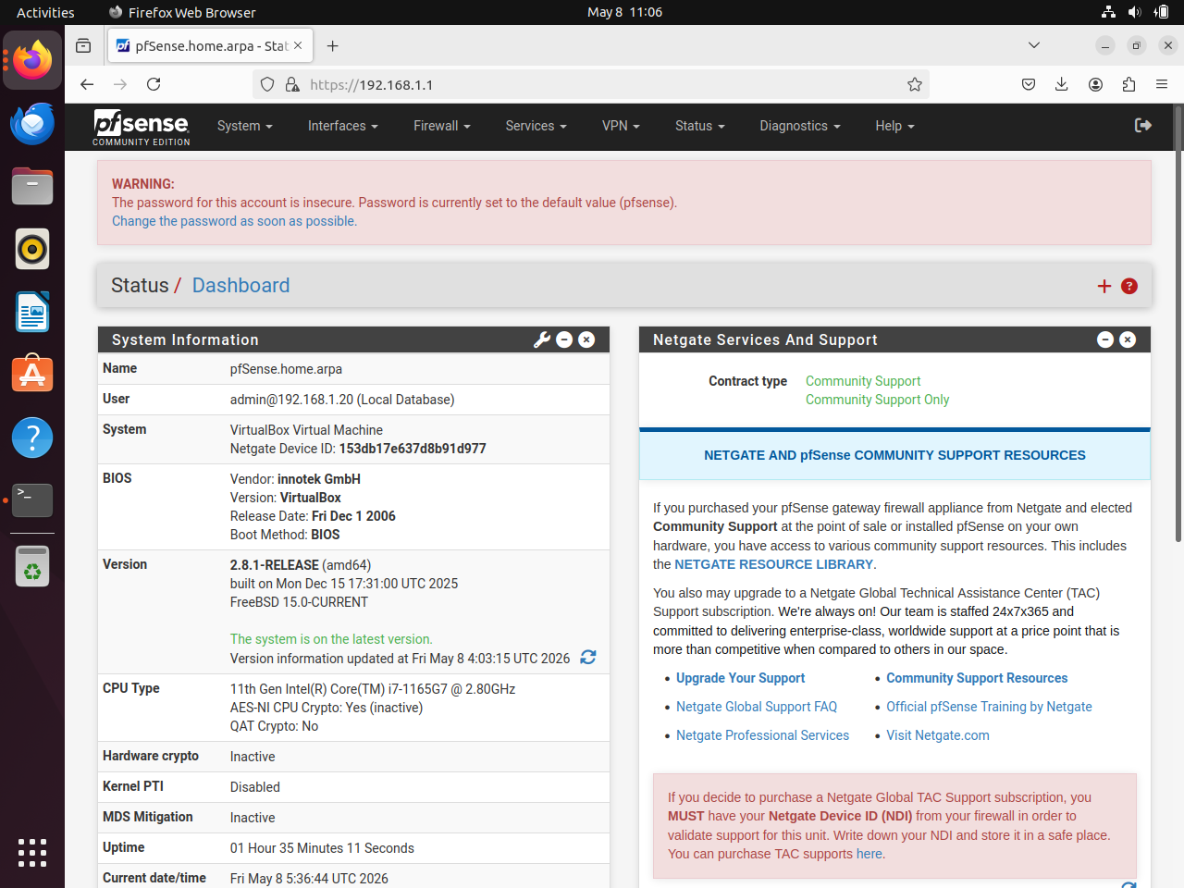
Figure 24 : pfSense Dashboard

Step 3 : Setting Up PC1 (Ubuntu Desktop)

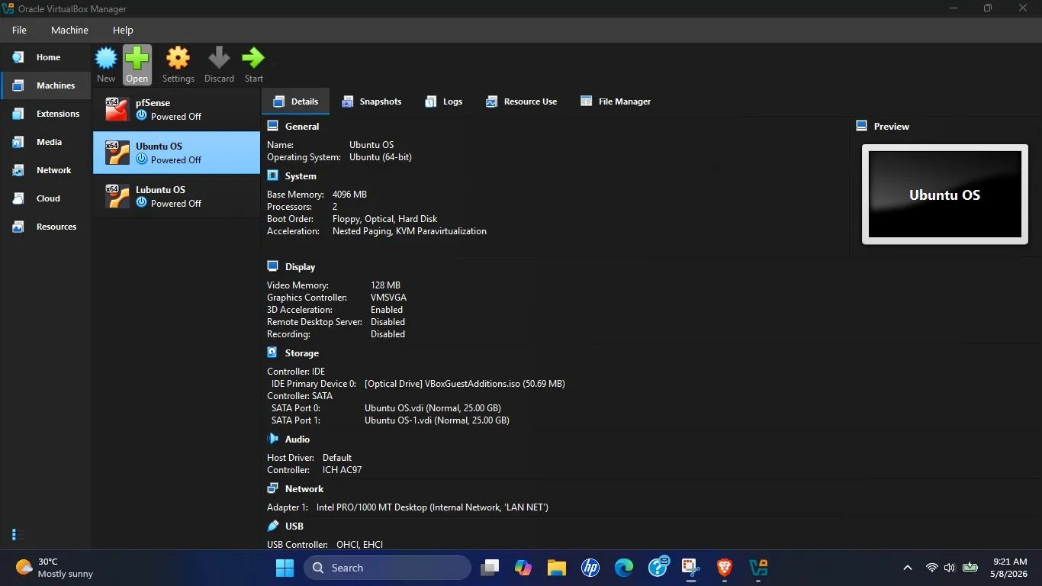
Ubuntu Desktop 64-bit was deployed as PC1 to simulate a standard enterprise workstation.
Figure 25 : Ubuntu VM Configuration
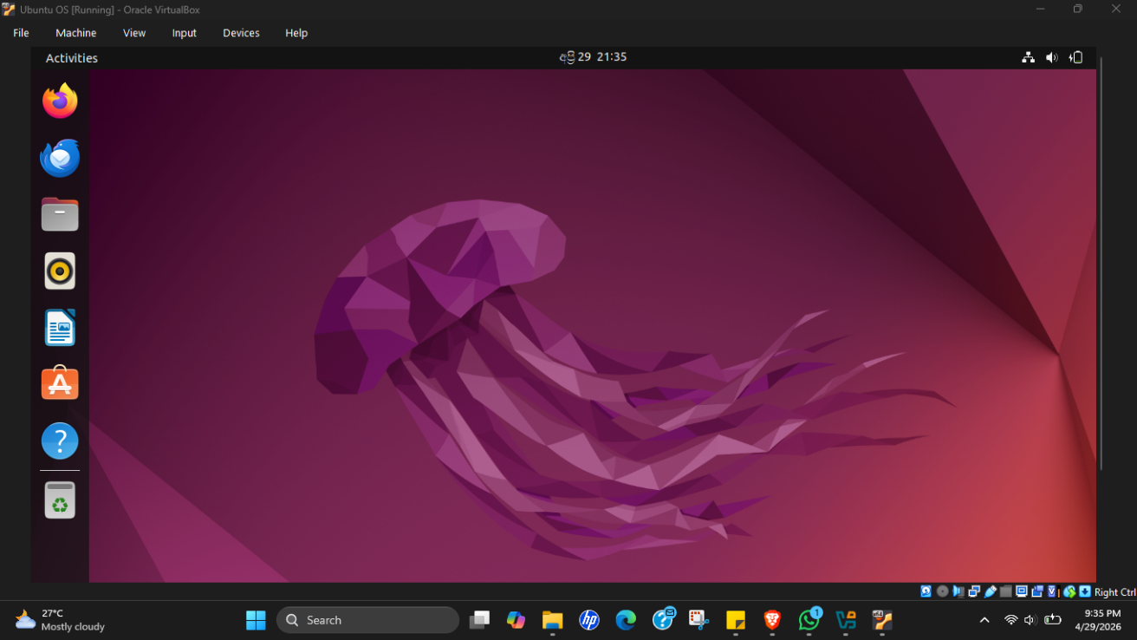
Ubuntu installed successfully without major issues and maintained stable performance throughout the implementation.
Figure 26 : Ubuntu OS Desktop

Step 4 : Setting Up PC2 (Lubuntu 24.04 LTS)

After evaluating multiple operating systems, Lubuntu 24.04 LTS was selected as the final operating system for PC2 due to its lightweight resource usage and stable VirtualBox compatibility.
Lubuntu was successfully installed using the graphical installer and operated efficiently alongside pfSense and Ubuntu on the 8GB host machine.
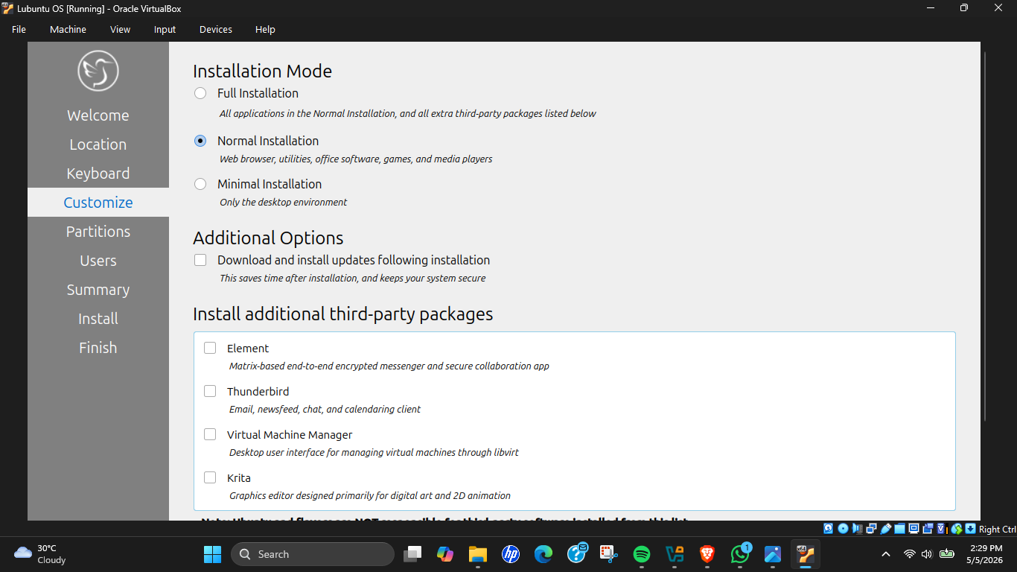
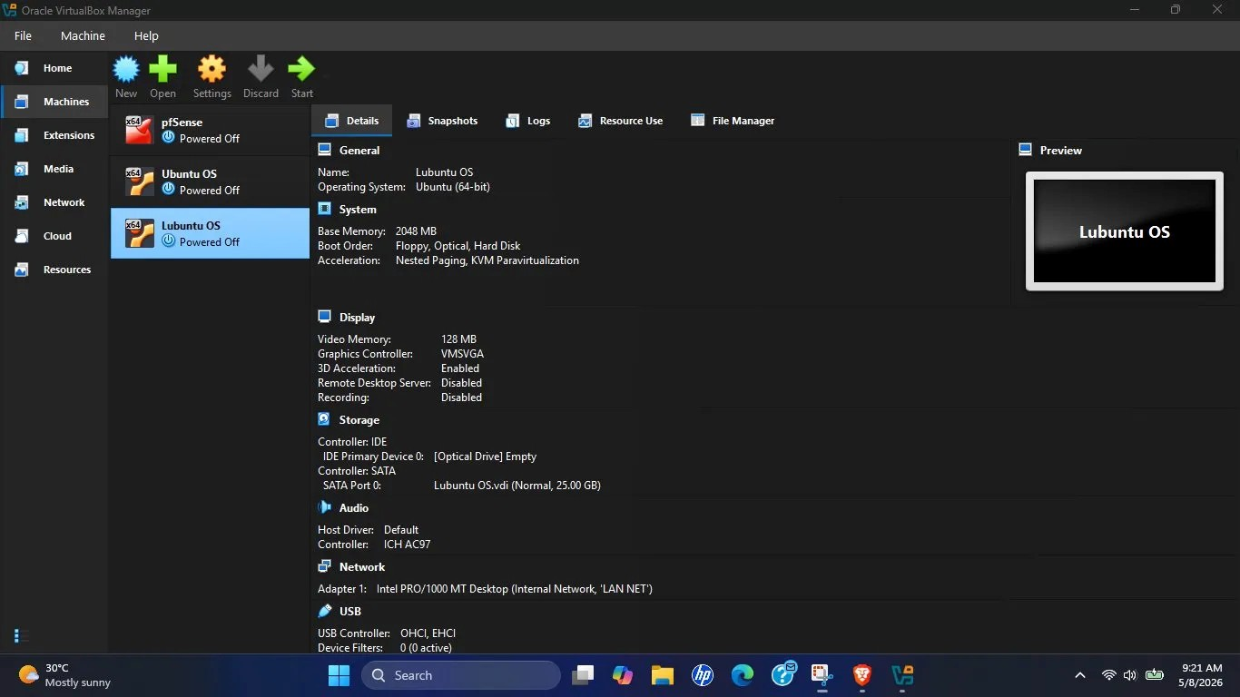
Figure 28 : Lubuntu Installation
Figure 27 : Lubuntu VM Configuration
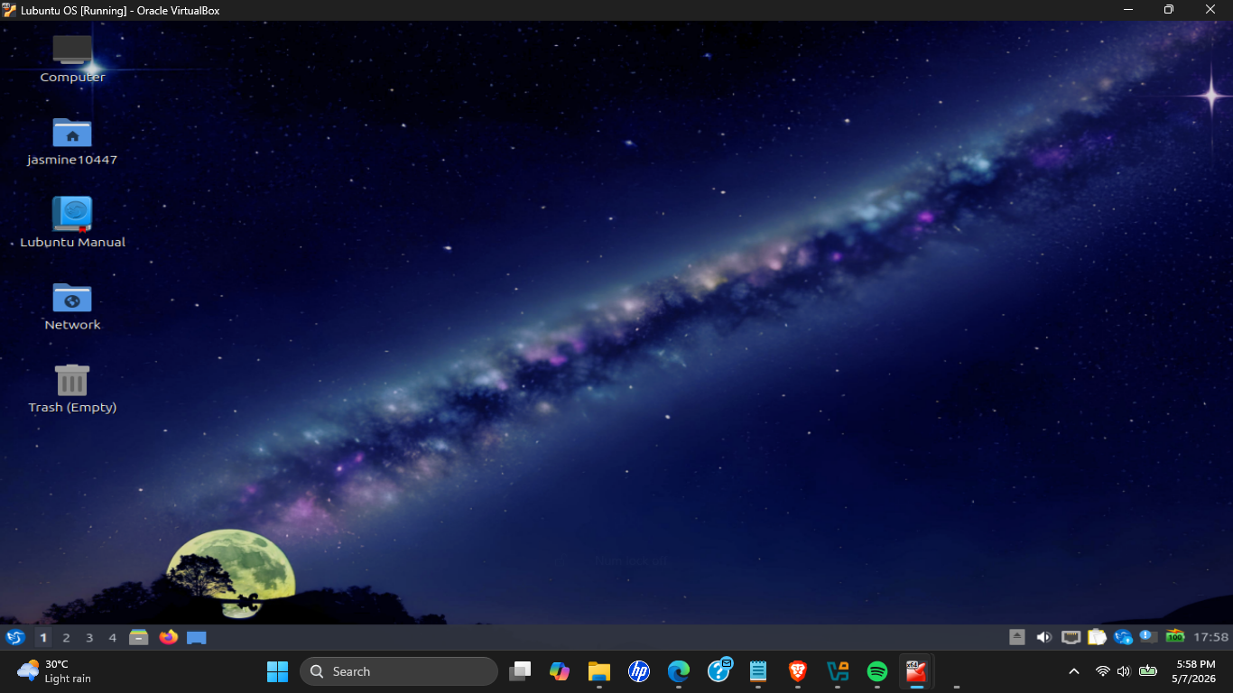
Figure 29 : Lubuntu OS Desktop

Challenges Faced & Troubleshooting

- Challenge 1 : Linux Mint Cinnamon Causing Host Machine Slowdown
Running Linux Mint Cinnamon simultaneously with pfSense and Ubuntu caused severe system lag due to excessive RAM consumption on the 8GB host machine.
Solution : Linux Mint Cinnamon was replaced with a lighter operating system. Lubuntu 24.04 LTS was ultimately selected because of its significantly lower resource usage and improved stability.

- Challenge 2 : Linux Mint MATE Installer Becoming Unresponsive
The Linux Mint MATE installer repeatedly froze during installation attempts despite successful VM creation and ISO configuration.
Solution : Several troubleshooting methods were attempted including:
- Increasing RAM allocation
- Increasing video memory
- Enabling 3D acceleration
- Testing compatibility installation mode
Since the issue persisted, the operating system has been replaced with Lubuntu 24.04 LTS, which was installed successfully without errors.

- Challenge 3 : VirtualBox Fullscreen Menu Bar Issue
While running Linux VMs in full screen mode, the VirtualBox menu bar became inaccessible, preventing access to runtime VM settings and the Devices menu.
Solution : The keyboard shortcut: Right Ctrl + F was used to exit full screen mode and restore access to the VirtualBox interface.

- Challenge 4 : Guest Additions Installation Difficulty
The standard Guest Additions CD installation method could not initially be accessed due to full screen limitations and interface unfamiliarity.
Solution : Guest Additions were installed directly using terminal commands instead of the CD image method:
sudo apt install virtualbox-guest-utils virtualbox-guest-x11 -y
This method successfully installed the required VirtualBox integration tools.

Task 02 : Creating Virtual Networks (VNets) & Establishing Connections

The objective of Task 02 was to create isolated virtual networks within Oracle VirtualBox and establish communication between pfSense, PC1 (Ubuntu), and PC2 (Lubuntu) to simulate a centralized enterprise network environment.

The task focused on configuring WAN and LAN connectivity, assigning appropriate virtual network adapters, establishing LAN communication, and ensuring that all client traffic passed through the pfSense firewall before reaching external networks.

Step-by-Step Configuration of Task 02

Step 1 : Configuring pfSense Network Adapters

The pfSense virtual machine was configured with two separate network adapters to simulate a real enterprise firewall environment containing both WAN and LAN interfaces.
Adapter | Type | Network | Purpose
Adapter 1 | Bridged Adapter | Realtek Wi-Fi | WAN Interface
Adapter 2 | Internal Network | LAN NET | LAN Interface
Table 3 : pfSense Network Adapter Details
Adapter 1 was configured in Bridged mode and attached directly to the host machine’s Realtek Wi-Fi adapter connected to the mobile hotspot. This allowed pfSense to obtain direct internet access through DHCP and function as the external gateway device. This isolated virtual LAN was used to connect both client machines internally through pfSense.
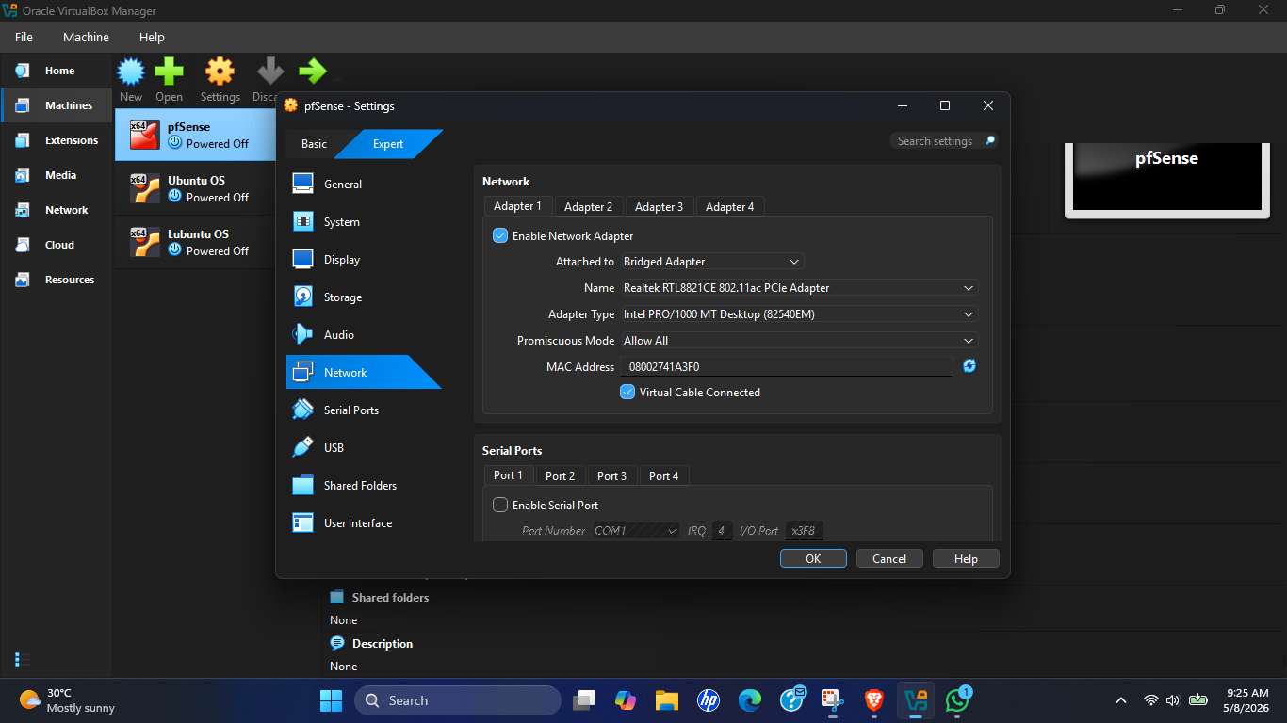
Figure 30 : pfSense WAN Adapter VM Config
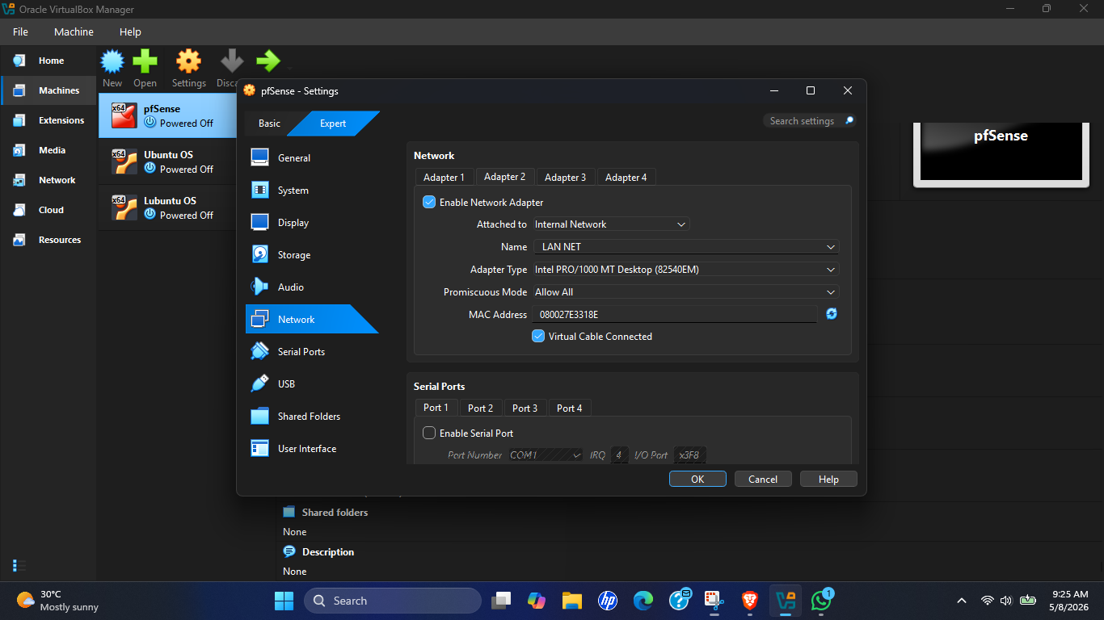
Figure 31 : pfSense LAN Adapter VM Config

Step 2 : Configuring Ubuntu (PC1) Network Adapter

The Ubuntu virtual machine was configured with a single network adapter connected to the Internal Network LAN NET. This ensured that Ubuntu remained fully isolated from direct internet access and could communicate externally only through the pfSense firewall.

The configuration simulated a standard enterprise workstation connected behind a perimeter firewall.

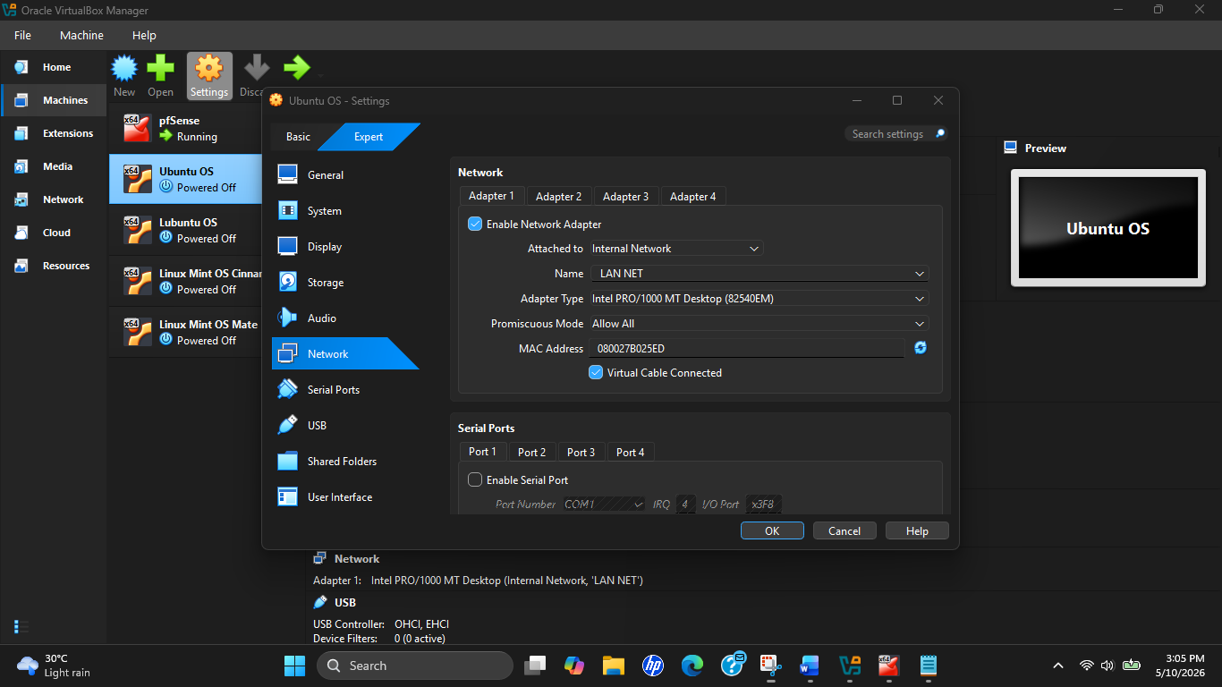
Figure 32 : Ubuntu LAN Adapter VM Config

Step 3 : Configuring Lubuntu (PC2) Network Adapter

The Lubuntu virtual machine was also connected to the same Internal Network LAN NET. Connecting both client systems to the same isolated LAN segment allowed pfSense to function as the centralized gateway device for all traffic routing and firewall policy enforcement.

This design also enabled separate firewall policies to later be applied individually based on client IP addresses.

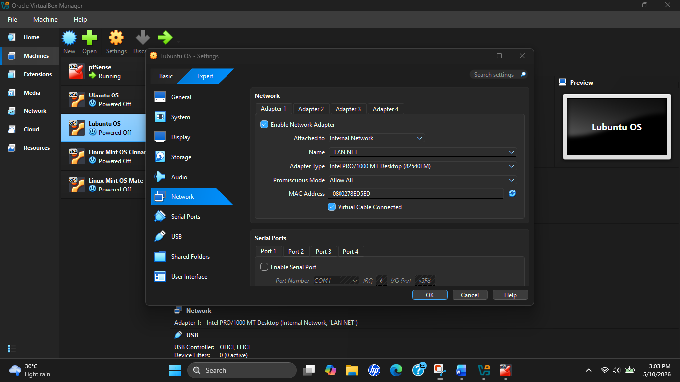
Figure 33 : Lubuntu LAN Adapter VM Config

Step 4 : Booting pfSense and Verifying Interface Assignment

After configuring the network adapters, pfSense was started first to initialize the WAN and LAN interfaces.

The pfSense console confirmed the following interface assignments:
Interface | Address | Purpose
WAN (em0) | 10.22.154.3/24 | External Internet Connection
LAN (em1) | 192.168.1.1/24 | Internal Gateway
Table 4 :pfSense Interface Assignment
The WAN interface successfully received an IP address dynamically from the mobile hotspot using DHCP, while the LAN interface was manually configured using the private subnet 192.168.1.0/24

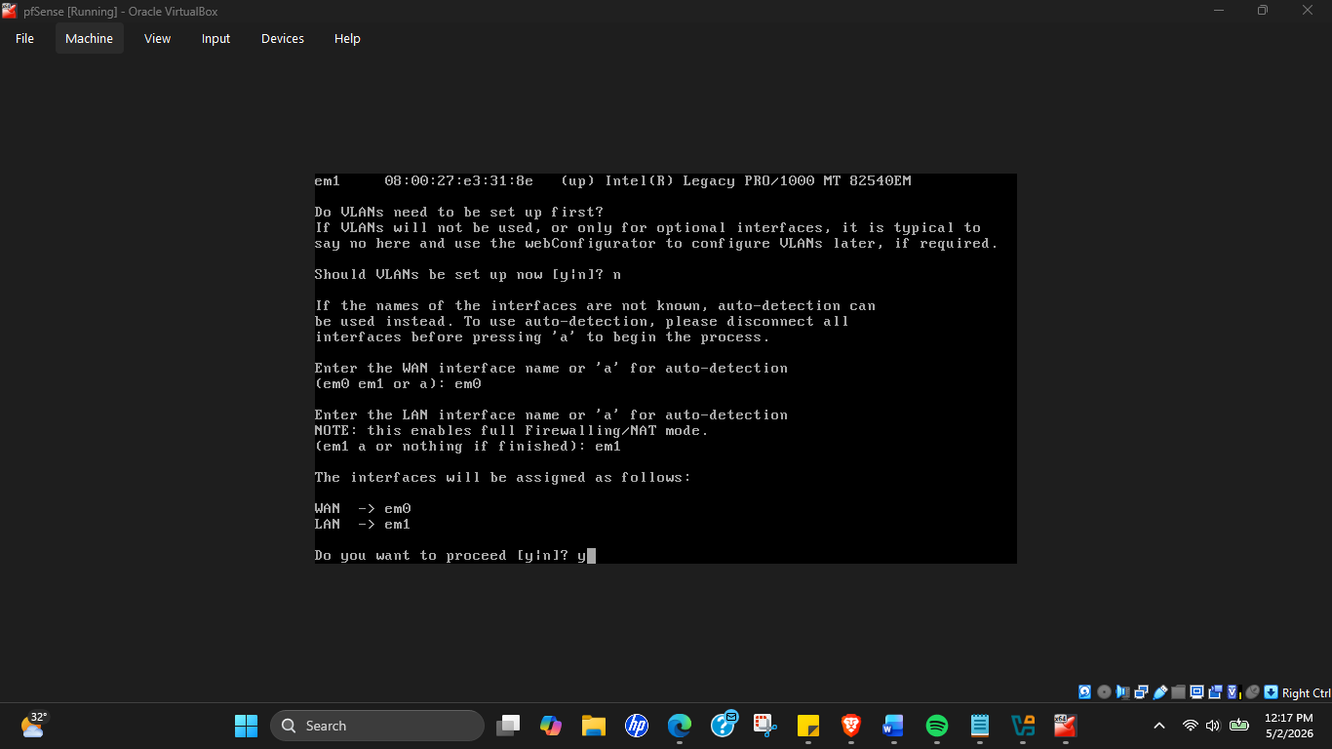
Figure 34 : pfSense Interface Setting
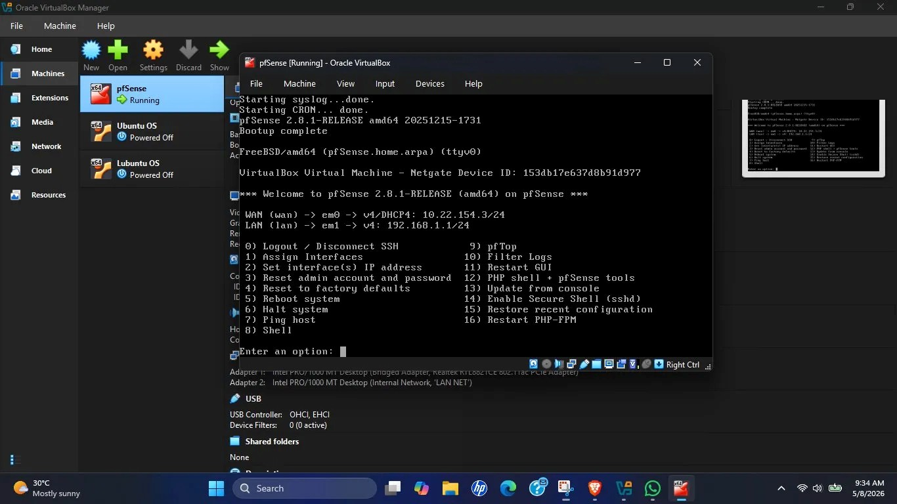
Figure 35 : pfSense Interface IPs

Step 5 : Verifying Ubuntu (PC1) Connectivity

Ubuntu was then started and network connectivity was verified and confirmed successful communication with the LAN NET segment and verified that Ubuntu was correctly connected behind the pfSense LAN interface.

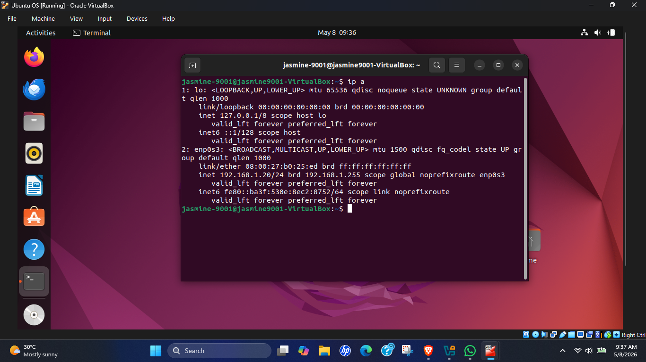
Figure 36 : Ubuntu IP Address Verification

Step 6 : Verifying Lubuntu (PC2) Connectivity

Lubuntu was then started and network configuration verified successful connectivity between Lubuntu and the pfSense LAN environment.

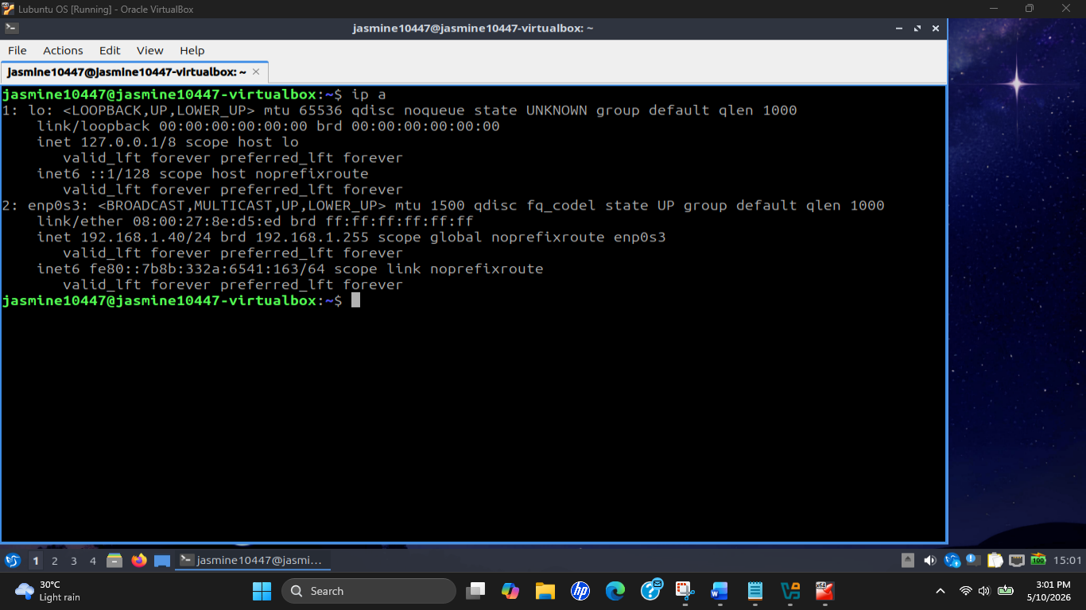
Figure 37 : Lubuntu IP Address Verification

Challenges Faced & Troubleshooting

- Challenge 1 : Incorrect Initial Network Adapter Configuration
During the initial setup process, Ubuntu was incorrectly configured with a Bridged Adapter as Adapter 1 and an Internal Network adapter as Adapter 2. This caused Ubuntu to bypass pfSense entirely and obtain direct internet access from the hotspot connection. At the same time, Lubuntu was connected only to the LAN NET internal network, meaning both client machines were operating on different network segments.
Resolution :The incorrect Bridged Adapter configuration was removed from Ubuntu and replaced entirely with the Internal Network: LAN NET. Both Ubuntu and Lubuntu were then connected to the same isolated LAN segment behind pfSense.

This ensured that all client traffic passed through the firewall before accessing external networks.
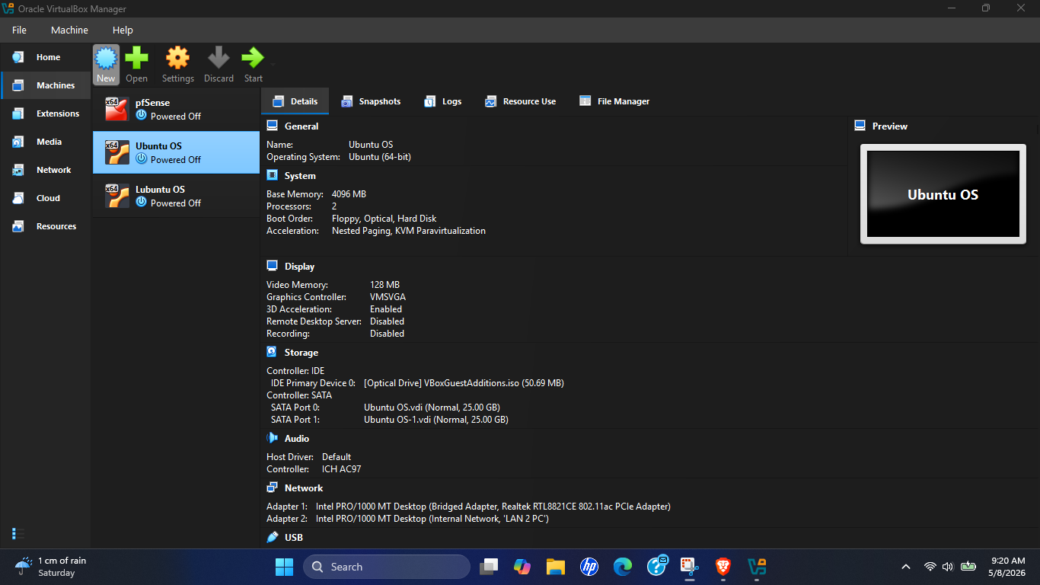
Figure 38 : Incorrect Network Configuration
Figure 39 : Fixed Network Configuration

- Challenge 2 : Previous DHCP Lease Conflict on Lubuntu
When Lubuntu was initially booted, the system displayed an older DHCP-assigned IP address from a previous configuration session rather than the intended final address. This created inconsistent network identification and could potentially interfere with later firewall rule implementation.
Solution : A static IP configuration was manually assigned through Lubuntu’s Network Manager using the following settings:
Setting | Addresses
IP Address | 192.168.1.40
Netmask | 255.255.255.0
Gateway | 192.168.1.1
DNS Server | 192.168.1.1
Table 5 : Lubuntu IP Setting
After applying the configuration, NetworkManager was restarted using:
sudo systemctl restart NetworkManager

This ensured stable and consistent network identification for PC2.

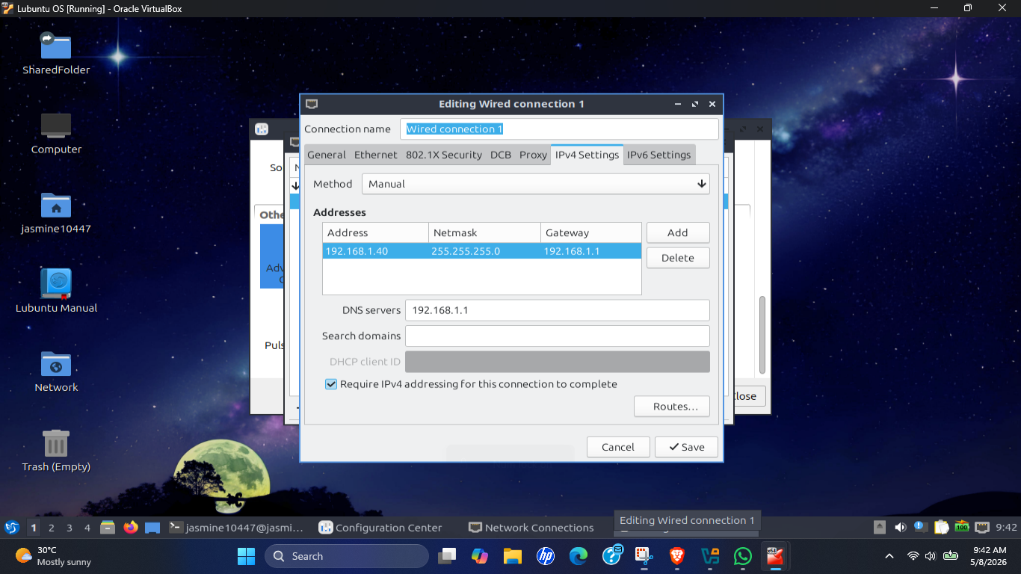
Figure 40 : Lubuntu Static IP Config

- Challenge 3 : Lubuntu Retaining Two Active IP Addresses
After configuring the static IP address, Lubuntu temporarily retained both the old DHCP address and the newly assigned static address simultaneously on the same interface. This resulted in two active IP addresses being associated with the network adapter.
Solution : The outdated DHCP-assigned address was manually removed using:
sudo ip addr del 192.168.1.104/24 dev enp0s3
However, this process also temporarily removed static configuration due to interface reinitialization.
The correct static address was then manually restored using:
sudo ip addr add 192.168.1.40/24 dev enp0s3
sudo ip route add default via 192.168.1.1

After reconfiguration, Lubuntu successfully retained only the correct static IP address.

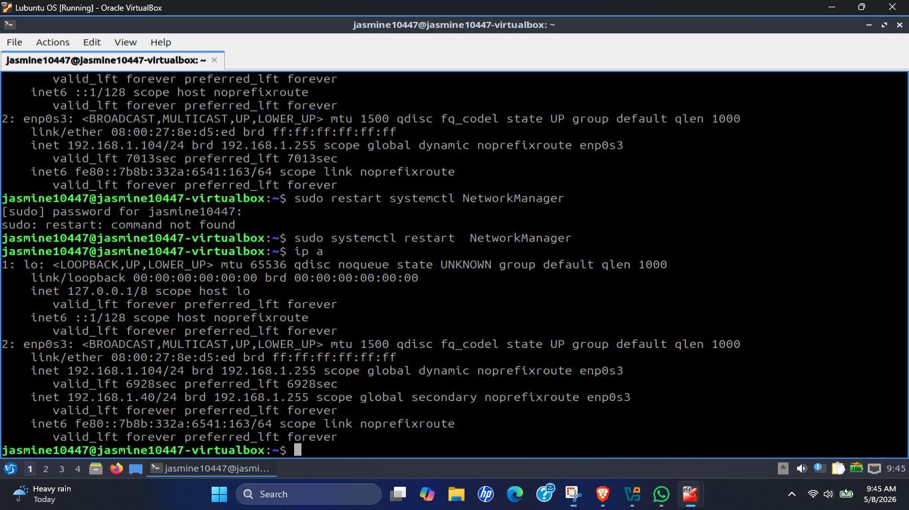
Figure 41 : Lubuntu Terminal with Two IPs
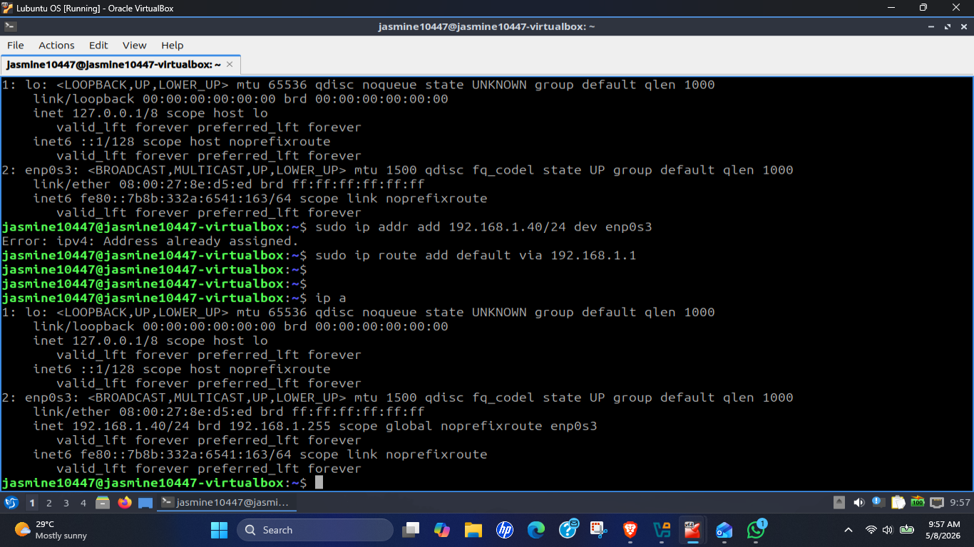
Figure 42 : Lubuntu Terminal with one IP

Task 03 : Enabling Internet Connectivity for PC1 and PC2

The objective of Task 03 was to provide internet connectivity to both Ubuntu (PC1) and Lubuntu (PC2) through the pfSense firewall using NAT (Network Address Translation). This task involved verifying WAN connectivity on pfSense, ensuring correct gateway configuration on both client systems, and testing internet access and DNS resolution through the centralized firewall environment.

Internet Connectivity in This Topology

The pfSense firewall automatically performs Network Address Translation (NAT) between the internal LAN subnet 192.168.1.0/24 and the WAN interface connected to the mobile hotspot.

Since the internal client machines use private IP addresses, they cannot directly communicate with external internet services. pfSense translates the private LAN addresses into the WAN interface address received from the mobile hotspot connection, allowing internet communication through a centralized gateway.

Both client systems used 192.168.1.1 as their default gateway address.
Figure 43 : pfSense Default Gateway IP Address

Internet Connectivity Verification : Ubuntu (PC1)

Test 1 - External Connectivity Test
The following command was used to test direct internet reachability through Google’s public DNS server. This confirmed successful outbound internet connectivity through pfSense.

Test 2 - DNS Resolution Test
The following command was used to verify DNS functionality. This confirmed that DNS resolution was functioning correctly through pfSense.
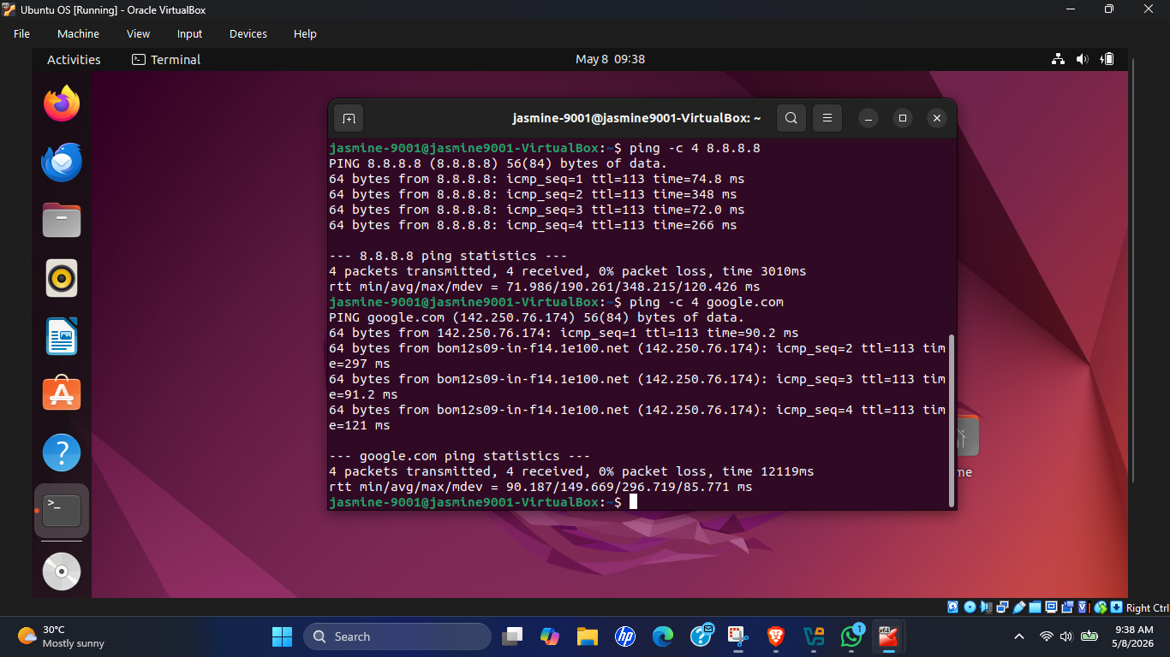
Figure 44 : Ubuntu PC1 Internet Connectivity

Internet Connectivity Verification : Lubuntu (PC2)

The same internet connectivity tests were then performed on Lubuntu. The successful response confirmed that Lubuntu could communicate externally through pfSense.
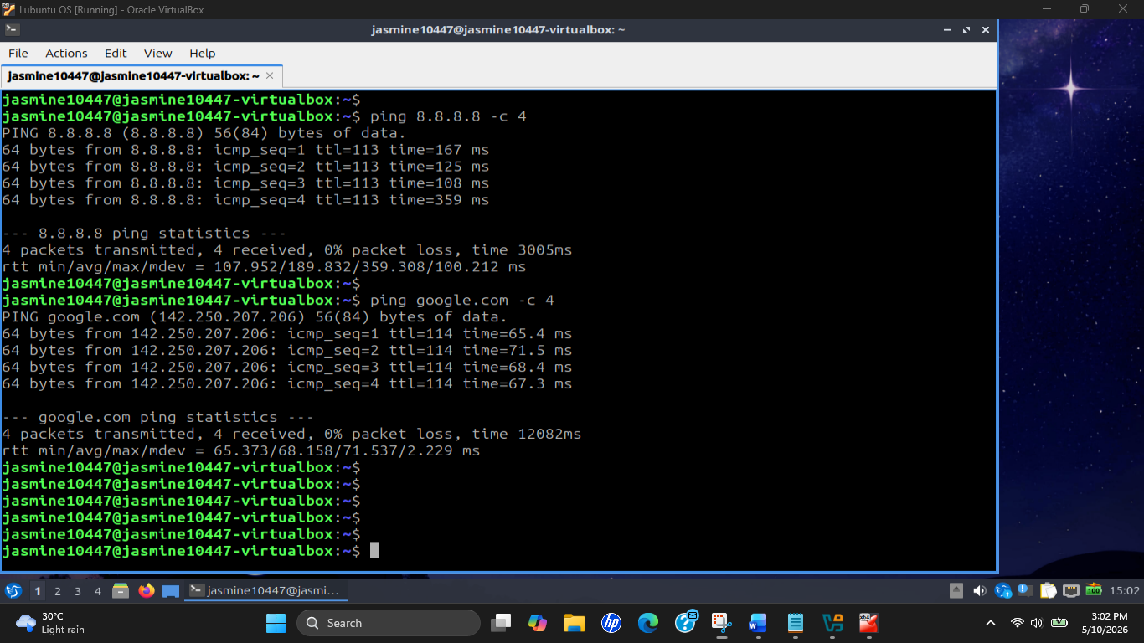
Figure 45 : Lubuntu PC2 Internet Connectivity

Final Network Connectivity Summary

Device | IP Address | Gateway | Internet Connectivity
pfSense WAN | 10.22.154.3 | Mobile Hotspot | Connected
pfSense LAN | 192.168.1.1 | — | Active
PC1 Ubuntu | 192.168.1.20 | 192.168.1.1 | Successful
PC2 Lubuntu | 192.168.1.40 | 192.168.1.1 | Successful
Table 6 : Network Connectivity Summary

Task 04 : Blocking Services for PC1 and PC2

The objective of Task 04 was to implement client-specific firewall restrictions using pfSense by
- Blocking YouTube access for PC1 (Ubuntu) while keeping WhatsApp accessible and
- Blocking WhatsApp access for PC2 (Lubuntu) while still allowing YouTube access.
This task demonstrated centralized enterprise firewall policy enforcement where different users or workstations can be assigned different internet access permissions based on organizational requirements.

Selected Approach : Firewall Rules with IP Aliases

After evaluating multiple filtering methods, firewall rules combined with pfSense IP aliases were selected as the final implementation approach. This method was chosen because firewall rules allow granular client-based filtering using source IP addresses. Different restrictions could therefore be applied independently to each workstation while maintaining unrestricted access for other devices on the same network.

The solution also closely resembles enterprise firewall deployments where user-specific internet policies are enforced through centralized firewall management.

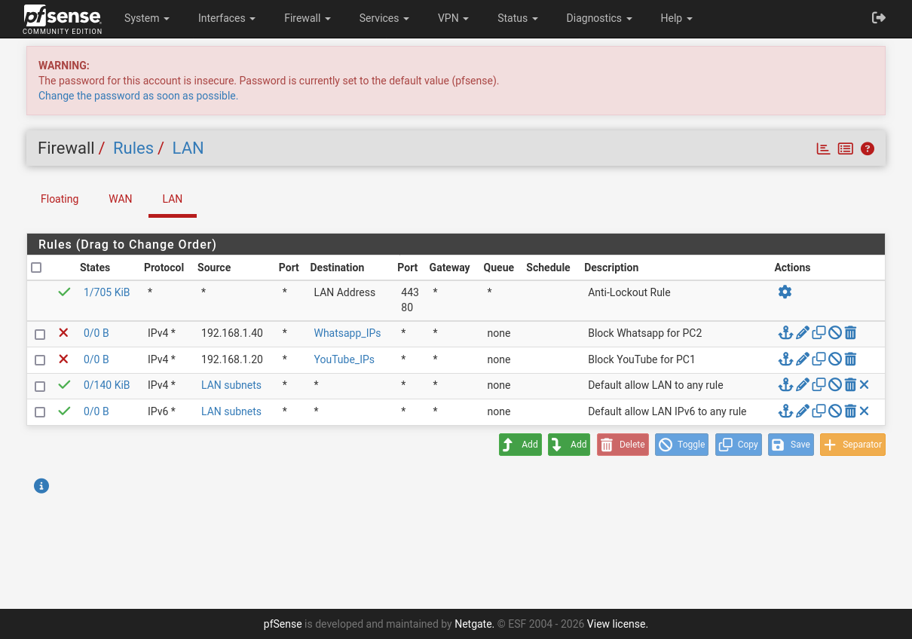
Figure 46 : Firewall Rules
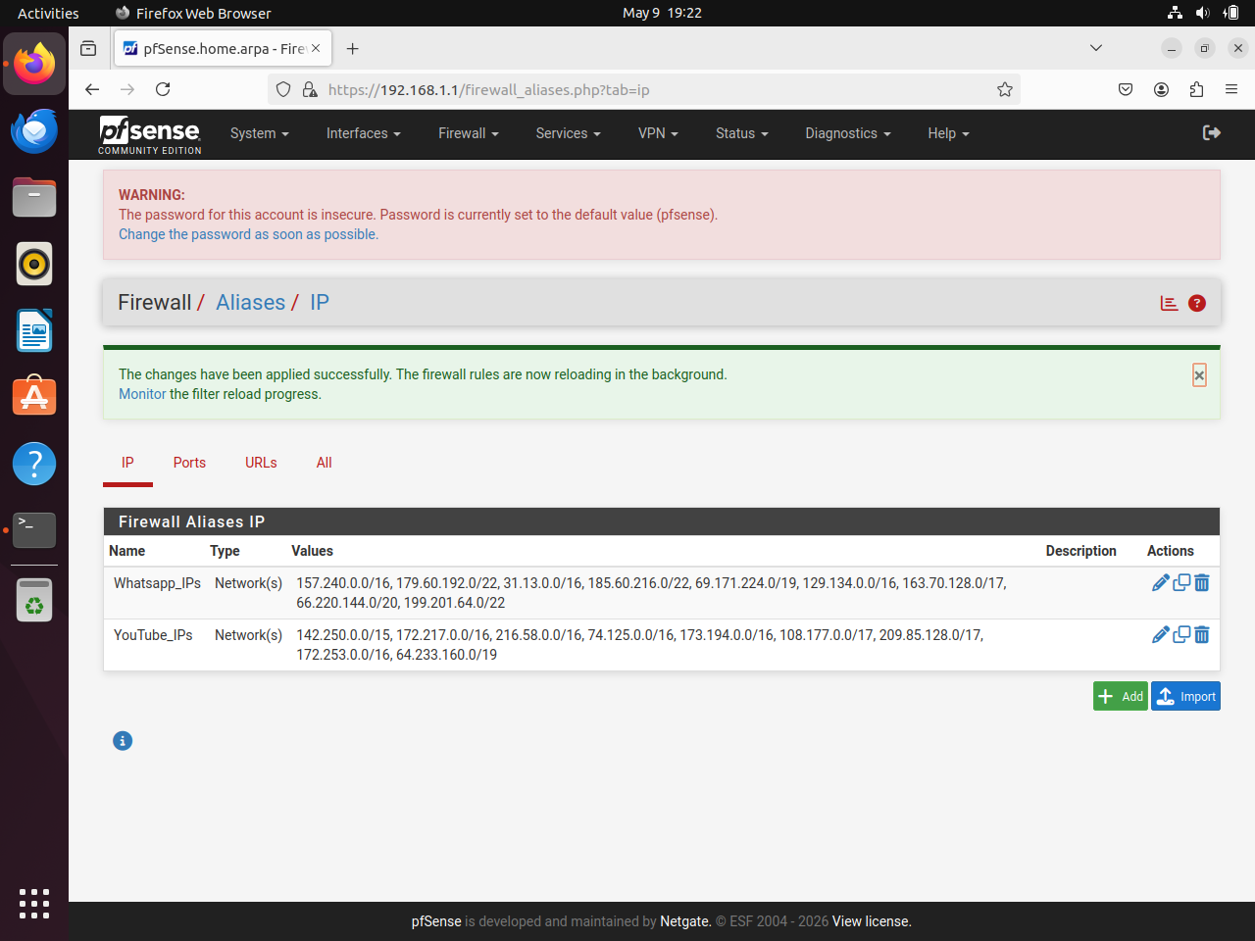
Figure 47 : pfSense Firewall Aliases
The final and successful implementation used pfSense firewall aliases together with LAN firewall rules.
This approach provided:
• Stable filtering behavior
• Client-specific policy enforcement
• Centralized management
• Greater reliability compared to DNS-based filtering

Methods Attempted Before Final Implementation

Before reaching the final solution, multiple filtering methods were tested and evaluated.

Method 1 - DNS Resolver Global Blocking

Initially, pfSense DNS Resolver custom options were configured to block YouTube domains directly through DNS filtering.

The following entries were added under:
Services → DNS Resolver → Custom Options
server:
local-zone: "youtube.com" always_nxdomain
local-zone: "googlevideo.com" always_nxdomain
local-zone: "ytimg.com" always_nxdomain

This method successfully blocked YouTube access. However, DNS Resolver filtering applies globally to all clients within the network environment.
As a result:
- YouTube became blocked for both PCs
- Client-specific filtering was not possible
- The assignment requirement could not be achieved
Therefore, this approach was considered unsuitable for the final implementation.
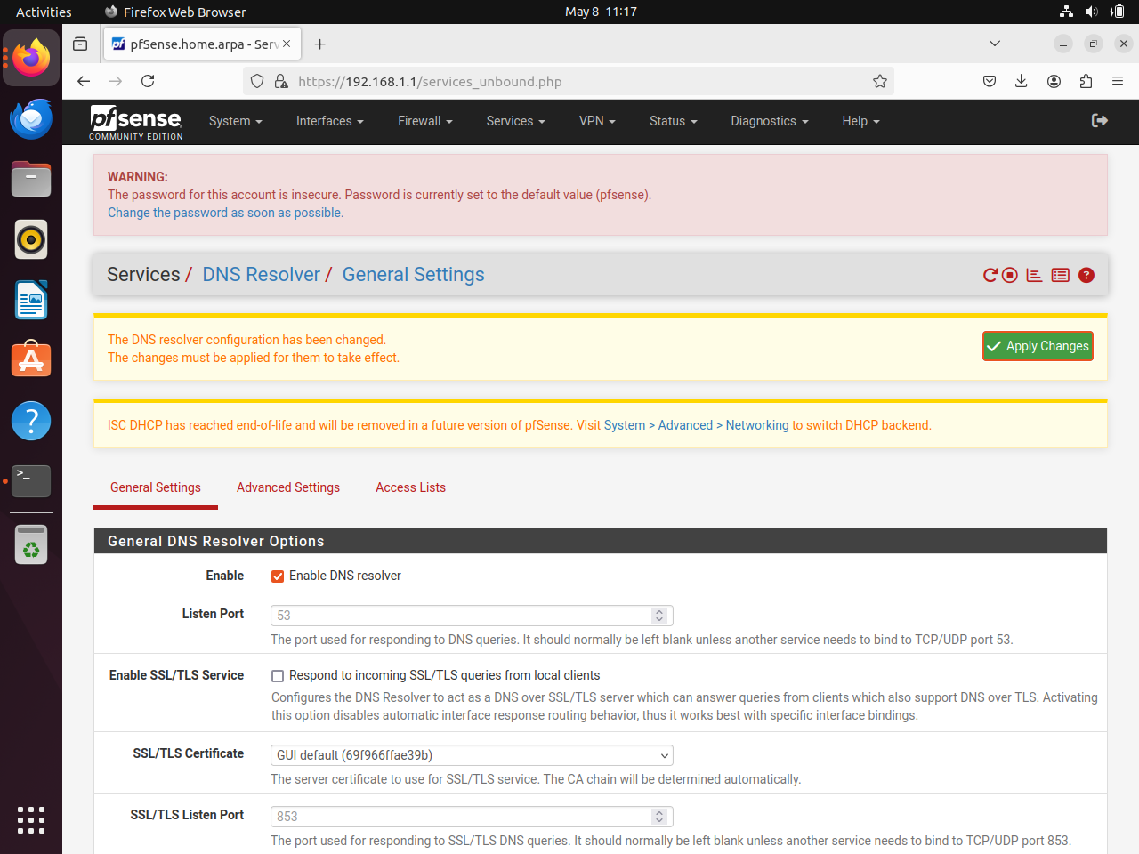
Figure 48 : pfSense Firewall - DNS Resolver pt.1
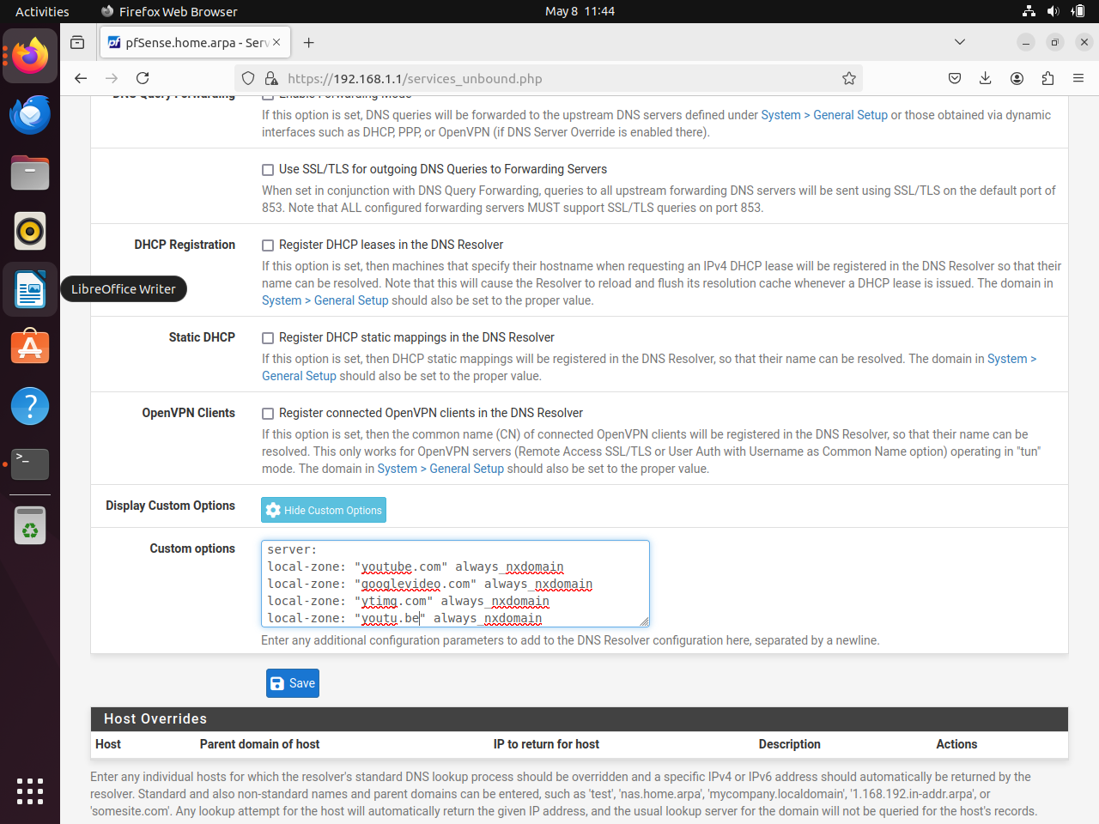
Figure 49 : pfSense Firewall - DNS Resolver pt.2

Method 2 - Hybrid DNS and Firewall Approach

A second approach attempted to combine DNS filtering with firewall-based filtering. The strategy involved:
- Blocking YouTube globally through DNS Resolver
- Configuring PC2 to use Google Public DNS: 8.8.8.8 to bypass the DNS restriction
- Blocking WhatsApp separately using firewall rules

However, this configuration introduced inconsistent behavior and network instability. Service accessibility became unpredictable and filtering results varied between testing sessions.

Due to the instability and unreliable filtering behavior, the hybrid approach was abandoned entirely.

Step-by-Step Configuration for Task 04

Step 1 : Clearing DNS Resolver Custom Options

All previously configured DNS Resolver custom entries were removed from:
Services → DNS Resolver → Custom Options
which are;
server:
local-zone: "youtube.com" always_nxdomain
local-zone: "googlevideo.com" always_nxdomain
local-zone: "ytimg.com" always_nxdomain
This ensured that DNS filtering no longer interfered with the firewall rule implementation.
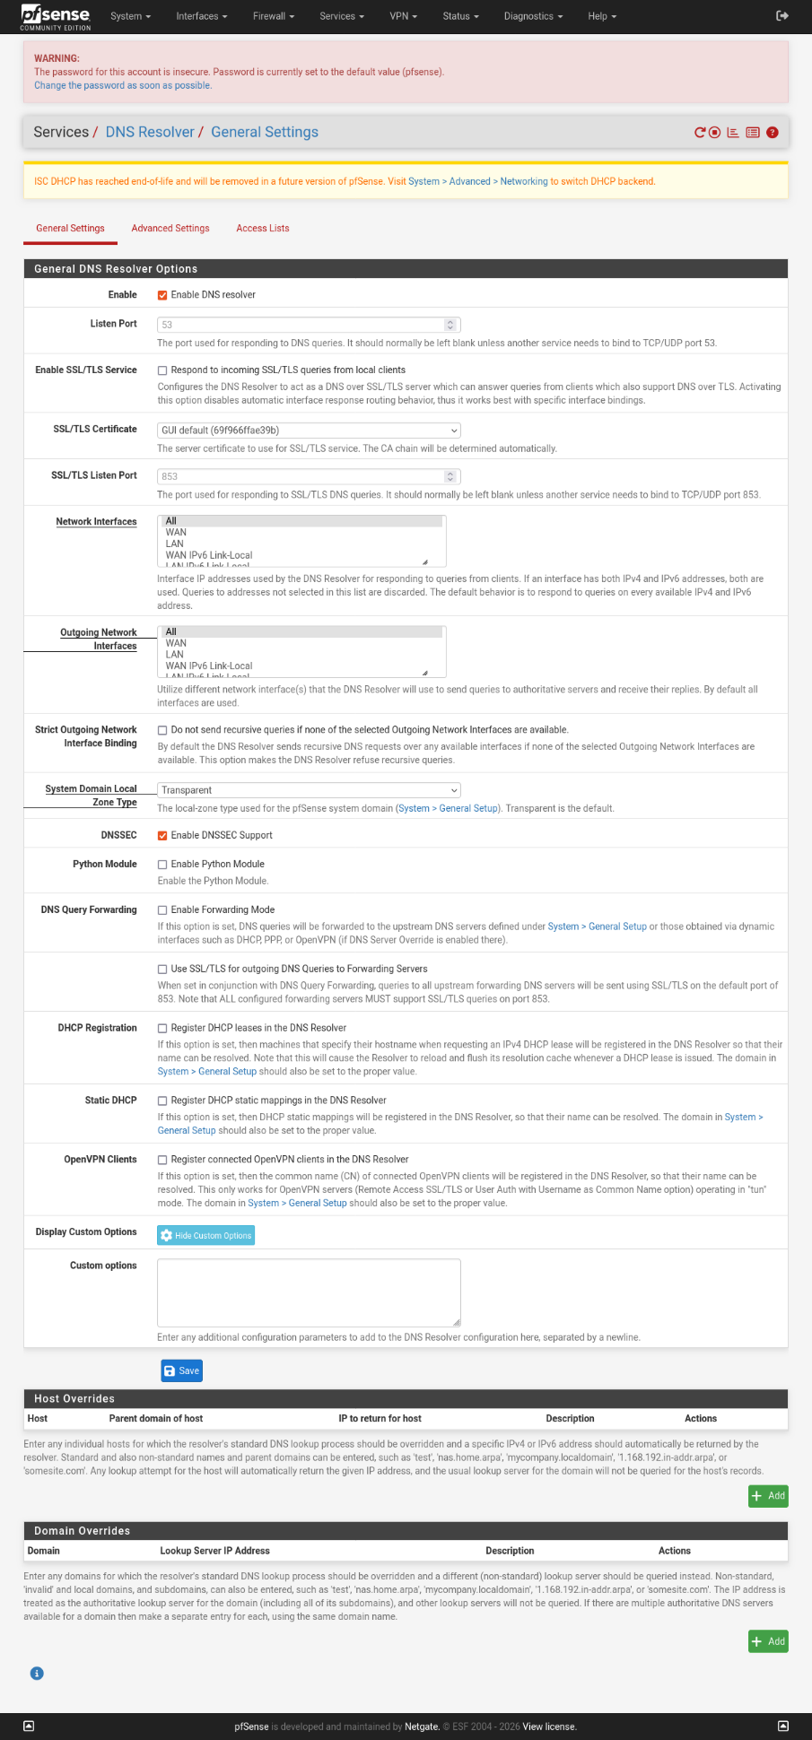
Figure 50 : pfSense Firewall - Clearing DNS Resolver

Step 2 : Creating the YouTube IP Alias

A pfSense alias named YouTube_IPs was created to group multiple known Google and YouTube IP ranges.The alias was configured under Firewall → Aliases → Add and the following network ranges were included:

142.250.0.0/15
172.217.0.0/16
216.58.0.0/16
74.125.0.0/16
173.194.0.0/16
108.177.0.0/17
209.85.128.0/17
172.253.0.0/16
64.233.160.0/19

These ranges were selected to maximize YouTube coverage during filtering and reduce the possibility of bypassing restrictions during testing.

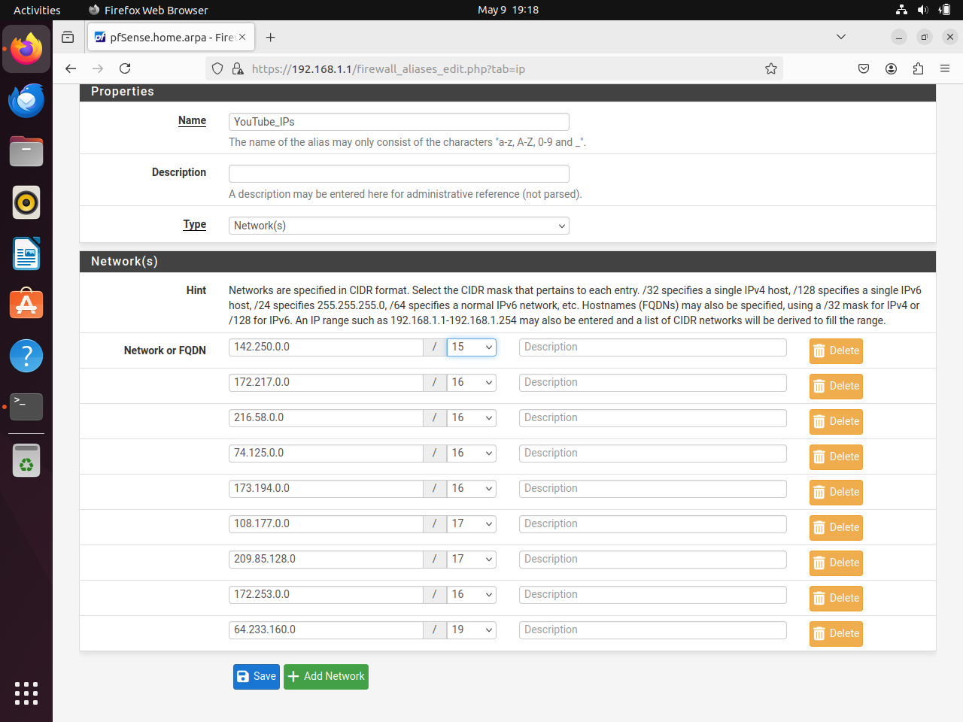
Figure 51 : pfSense Firewall YouTube_IPs Alias

Step 3 : Creating the WhatsApp IP Alias

A second alias named WhatsApp_IPs was created containing known Meta and WhatsApp network ranges and the following IP ranges were added:
157.240.0.0/16
179.60.192.0/22
31.13.0.0/16
185.60.216.0/22
69.171.224.0/19
129.134.0.0/16
163.70.128.0/17
66.220.144.0/20
199.201.64.0/22

The alias allowed multiple destination networks to be grouped under a single reusable firewall object.

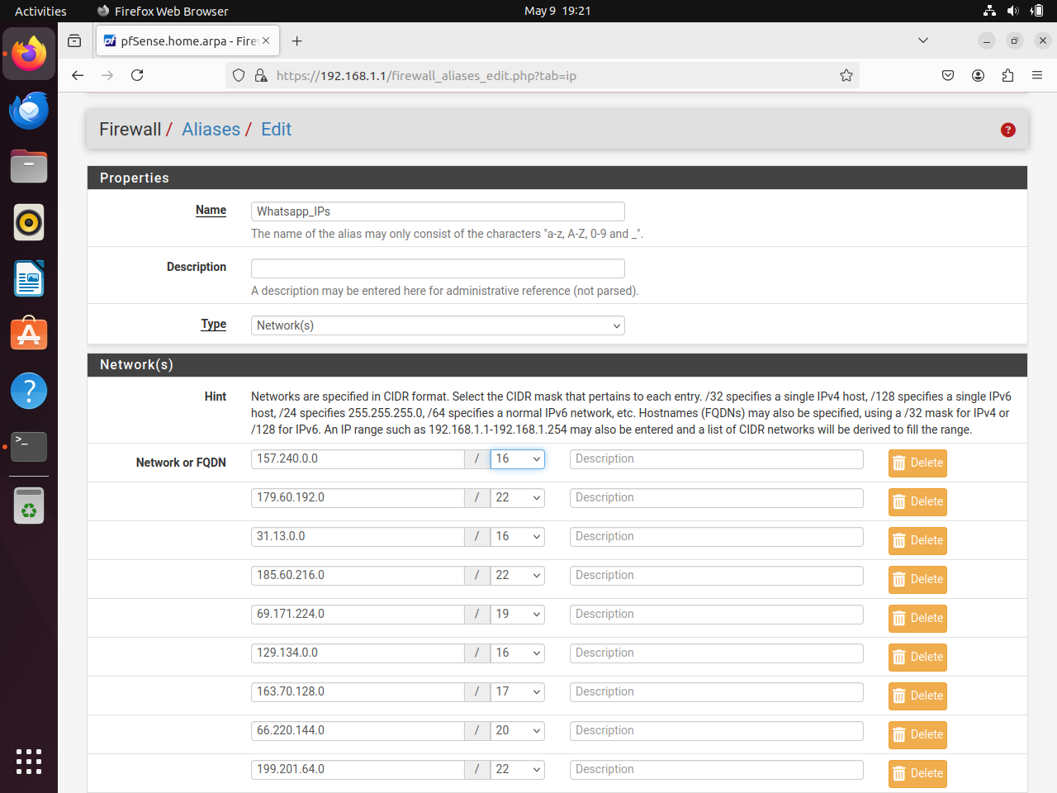
Figure 52 : pfSense Firewall WhatsApp_IPs Alias

Step 4 : Creating Firewall Rule to Block YouTube for PC1

A LAN firewall rule was created to block Ubuntu PC1 from accessing any IP addresses included within the YouTube_IPs alias.

This rule ensured that only Ubuntu PC1 was denied access to YouTube services while other systems remained unaffected.
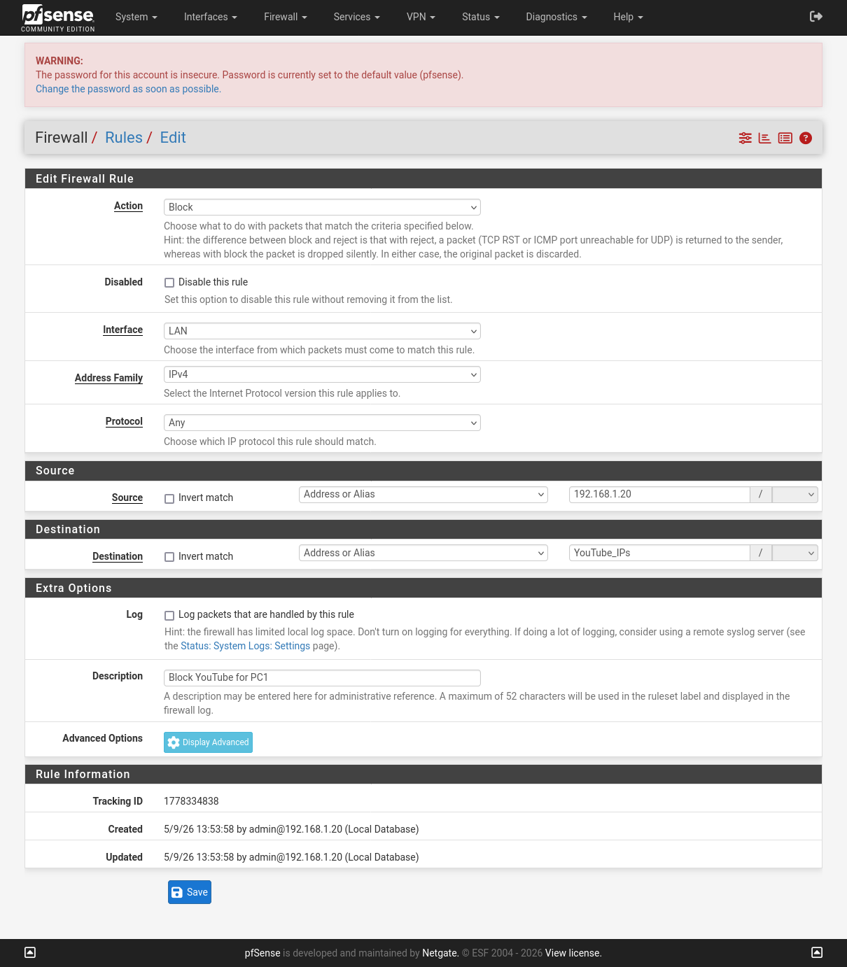
Figure 53 : pfSense Firewall Rule PC1

Step 5 : Creating Firewall Rule to Block WhatsApp for PC2

A second firewall rule was then created to block Lubuntu PC2 from accessing the WhatsApp_IPs alias.

This rule ensured that WhatsApp became inaccessible only for PC2 while remaining accessible on Ubuntu PC1.
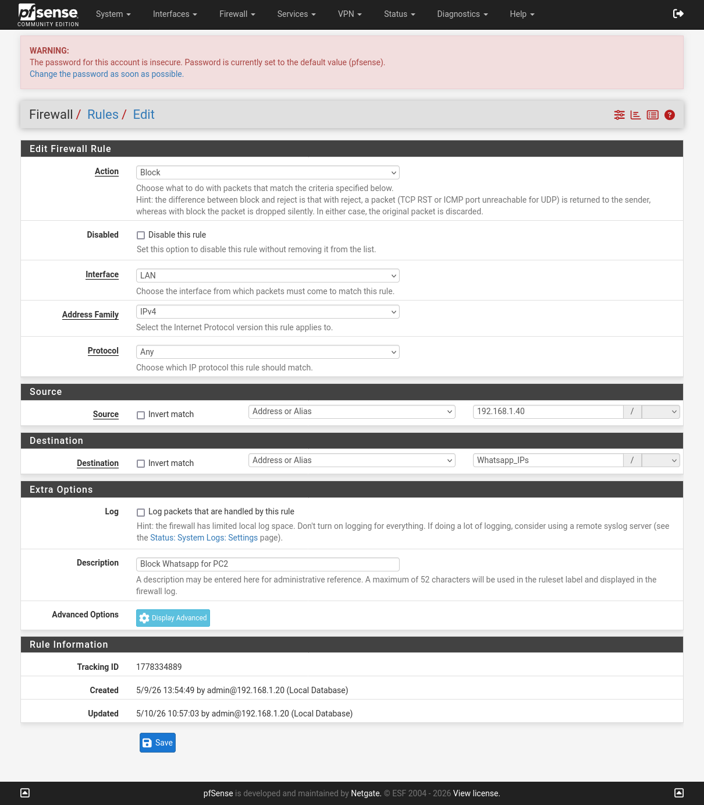
Figure 54 : pfSense Firewall Rule PC2

Step 6 : Applying Changes and Flushing DNS Cache

After creating the firewall rules, the configuration changes were applied within pfSense.
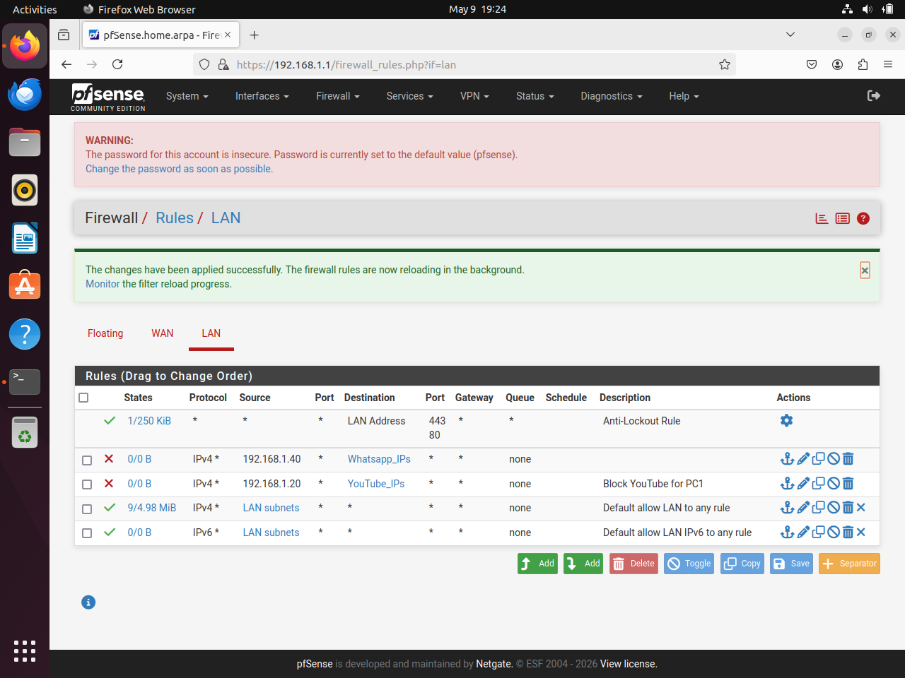
Figure 55 : pfSense Firewall Rules Applied

To ensure that no previously cached DNS entries interfered with testing, DNS cache was flushed on both client systems using:
sudo resolvectl flush-cache
This ensured accurate verification of the newly applied firewall restrictions.

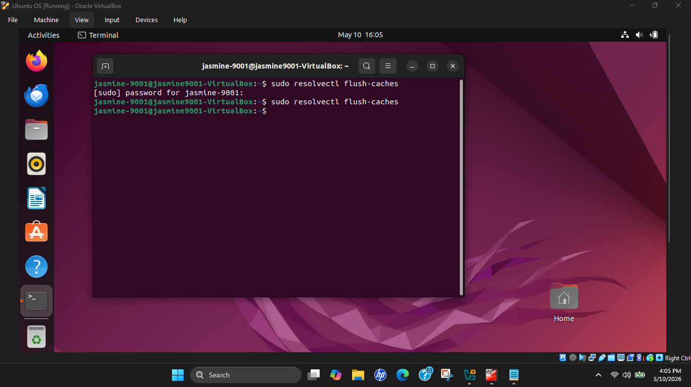
Figure 56 : DNS Flush on PC1

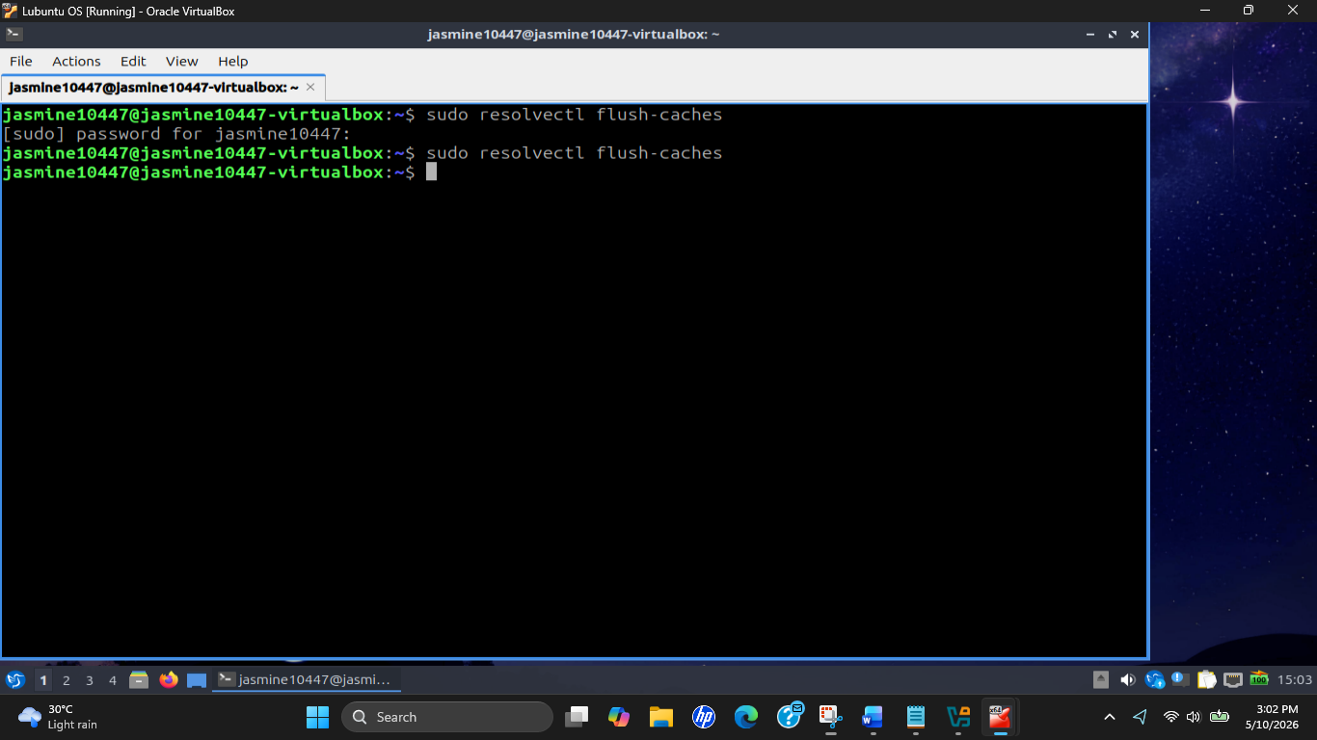
Figure 57 : DNS Flush on PC2

Challenges Faced & Troubleshooting

- Challenge 1 : DNS Resolver Filtering Applied Globally
The initial DNS Resolver approach successfully blocked YouTube access but affected all devices on the network equally. This violated the assignment requirement because YouTube needed to remain accessible on PC2 while being blocked only on PC1.
Solution : DNS Resolver custom options were completely removed, and the implementation was redesigned using firewall rules based on source IP addresses, enabling independent filtering policies for each workstation.

- Challenge 2 : Hybrid DNS and Firewall Configuration Caused Instability
The combined DNS and firewall approach produced inconsistent results and unreliable filtering behavior. Different services occasionally bypassed restrictions or became inaccessible unexpectedly.
Solution : The hybrid approach was abandoned completely. A clean firewall-rule-only configuration was implemented from scratch to improve reliability and simplify troubleshooting.

- Challenge 3 : Concern About Incomplete IP Range Coverage
Initially, only a small number of YouTube and WhatsApp IP ranges were added to the aliases. This created concern that some services might still remain accessible through unlisted network ranges during the final demonstration or viva session.
Solution : Additional Google and Meta IP ranges were researched and added to both aliases to maximize service coverage and improve filtering reliability. The final configuration included nine IP ranges per alias.
Testing confirmed that the firewall rules functioned exactly as intended without affecting unrelated internet services.
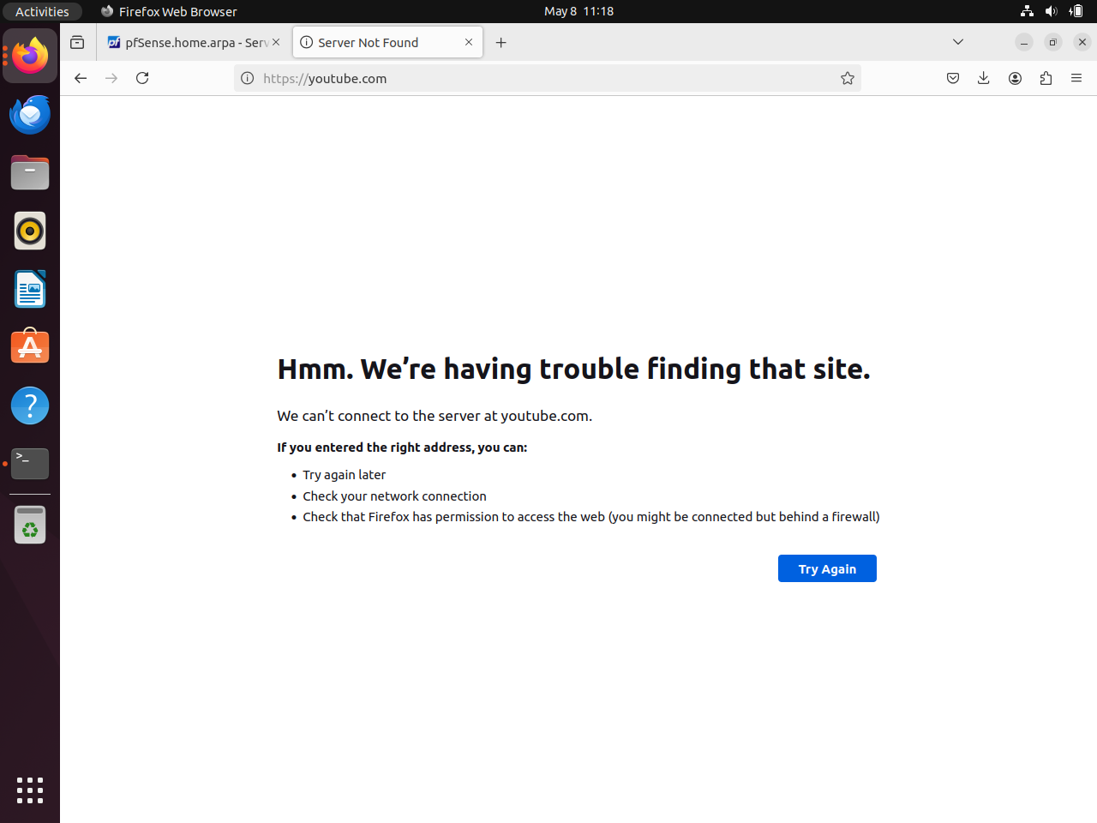
Figure 58 : PC1 YouTube Blocked Result
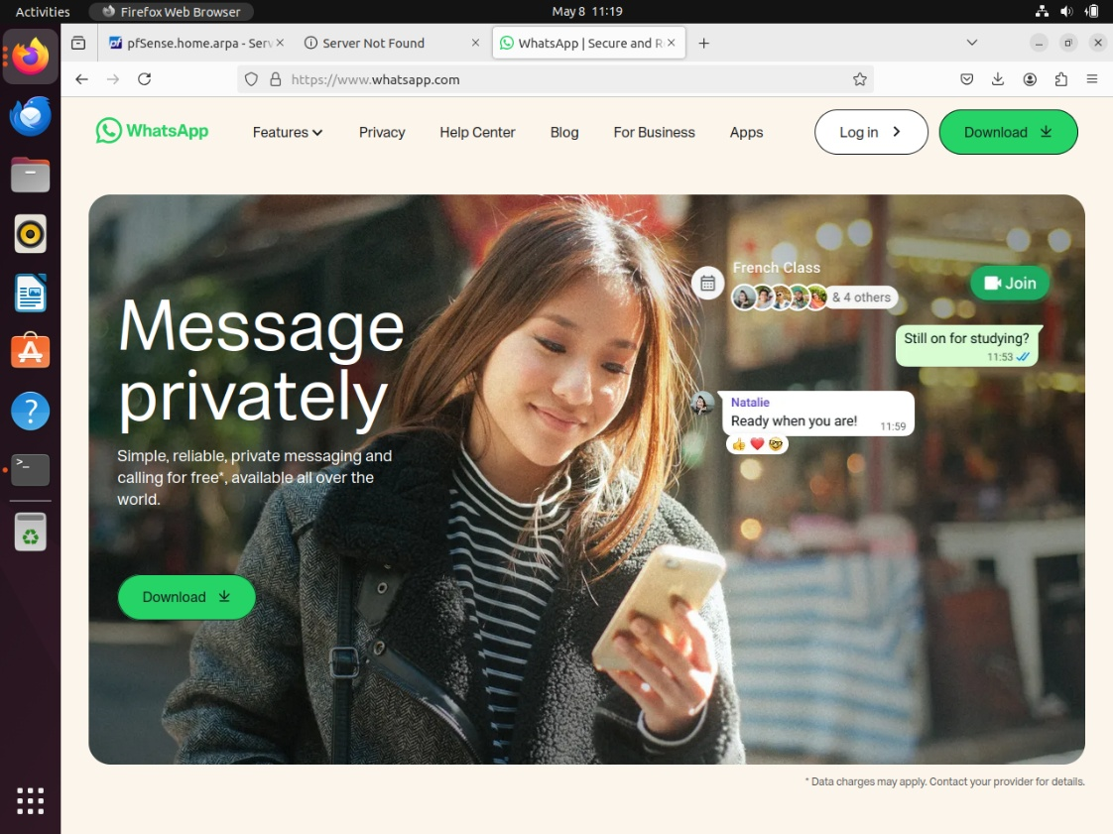
Figure 59 : PC1 WhatsApp Access Result

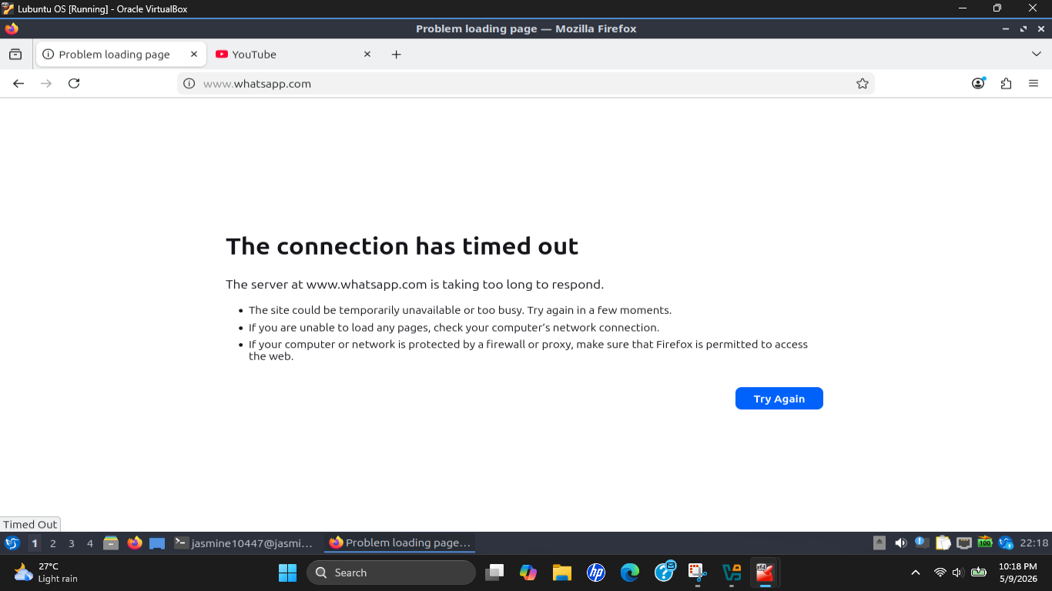
Figure 60 : PC2 WhatsApp Blocked Result
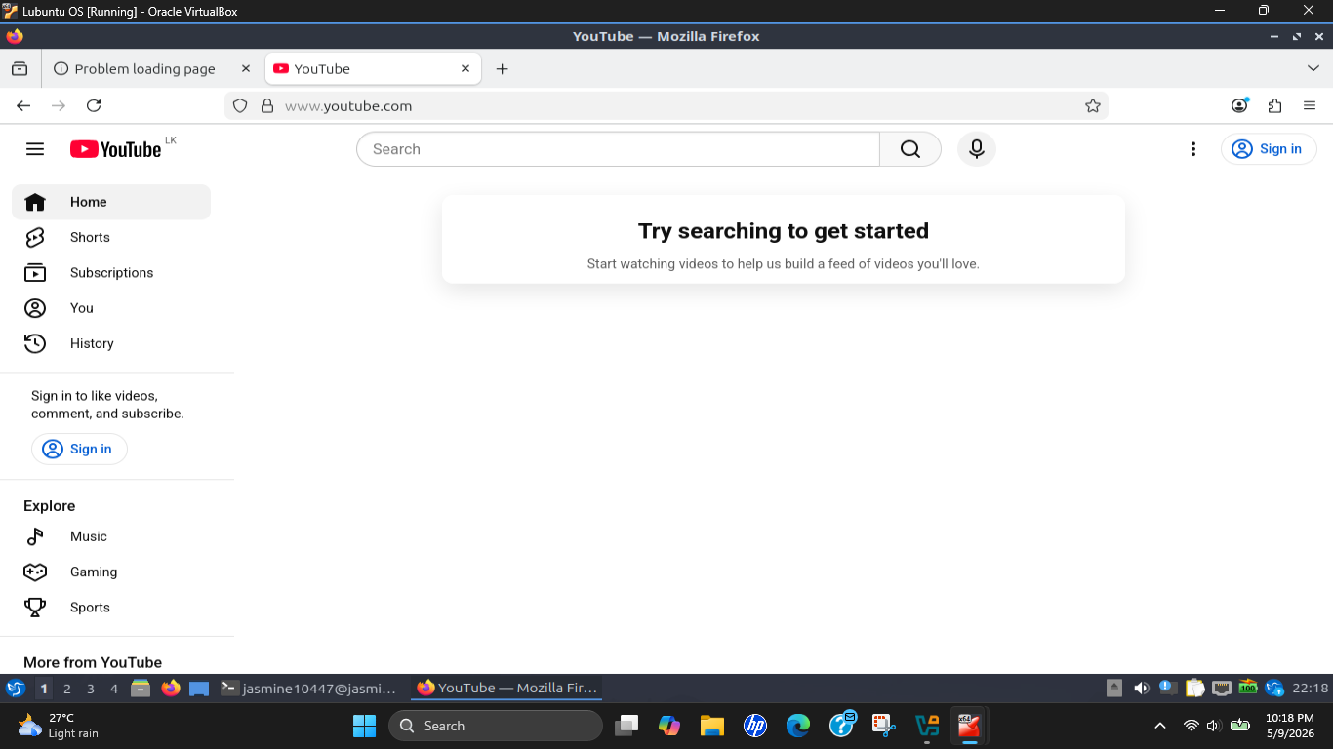
Figure 61 : PC2 YouTube Access Result

Conclusion

This assignment successfully showed the design, deployment, configuration and testing of a virtualized enterprise network environment, using Oracle VirtualBox and pfSense. The final configuration was a single pfSense firewall/router with two client machines connected in an isolated LAN environment, one running Ubuntu Desktop (PC1) and the other Lubuntu 24.04 LTS (PC2), with the latter using a mobile hotspot WAN connection to the internet. All assignment objectives from Tasks 01 to 04 were completed successfully.

Three virtual machines were created with proper WAN and LAN segmentation to create a fully functional virtual environment. The centralized firewall/gateway device was configured to be pfSense; internet connectivity for both client systems was provided by Network Address Translation (NAT). Client specific firewall policies were also successfully configured with pfSense firewall rules and IP aliases, blocking access to YouTube for PC1 and WhatsApp for PC2 and preserving access to other services.

Some practical issues were faced during implementation such as failure of OS installation, virtual machine performance, misconfigurations of the network, DHCP conflicts, DNS filtering limitations. These problems were solved and represented good practical experience in troubleshooting, configuring the firewall, virtualization, traffic filtering, and enterprise network management in a simulated real-world networking environment.

Lessons Learned

1. Resource Planning is Important in Virtualized Environments
The use of multiple virtual machines running concurrently on a host system that only had 8GB of RAM highlighted the need for correct resource allocation and operating system selection. Compared to the heavier desktop environments like Linux Mint Cinnamon, the lightweight operating systems like Lubuntu, proved to be better in terms of performance and stability of the system. This showed how the performance of virtualization will be affected by hardware limitations within enterprise lab environments.

2. Firewall Rules Provide Better Granular Control than DNS Blocking
The most valuable thing that was learned is that there is a distinction between DNS-based filtering and firewall-based filtering. DNS Resolver blocking in pfSense is implemented at the global level for all the devices on the network. This proved successful in blocking services but was not suitable for blocking individual clients separately. Firewall rules based on source IP address was found to be a more appropriate enterprise level solution, as different internet policies were being applied to individual workstations.

3. Static IP Addressing Simplifies Firewall Policy Management
Implementing firewall rules with manually assigned static IPs was much more reliable and manageable. Static addressing guarantees that a client device would always have the same IP address, which would eliminate the problem of mismatching firewall rules due to changing DHCP leases. This pointed out the need for predictable addressing in enterprise network environments where security policies are based on device identification.

4. pfSense Aliases Improve Firewall Scalability and Management
Using pfSense aliases made the management of firewall rules much more manageable because it allowed several similar IP ranges to be put into objects that can be reused. Aliases led to cleaner and more scalable firewall configurations rather than multiple individual firewall rules. This technique allows for the adoption of common practice in enterprise firewalls, which typically involve network objects and aliases for rule administration.

5. NAT is Essential for Private LAN Internet Connectivity
The assignment involved hands-on experience with how Network Address Translation (NAT) can facilitate communication between private internal networks and external Internet services. pfSense automatically converted internal LAN addresses to the WAN interface address received from the mobile hotspot connection to utilize a single external internet connection in a secure manner with multiple internal devices. One of the critical networking lessons to learn was the understanding of NAT operating between WAN / LAN environments.

6. Troubleshooting is a Critical Networking Skill
There were a few technical problems encountered during the assignment, such as:

- Linux Mint installation failures
- Virtual machine performance limitations
- Incorrect Network adapters
- DHCP lease conflicts
- DNS filtering limitations
- Multiple IP address conflicts

For each issue, systematic troubleshooting, careful analysis and alternative implementation approaches were required. This underscored the value of patience, flexibility, and a structured approach to problem-solving when it comes to enterprise network deployments.

